Window function

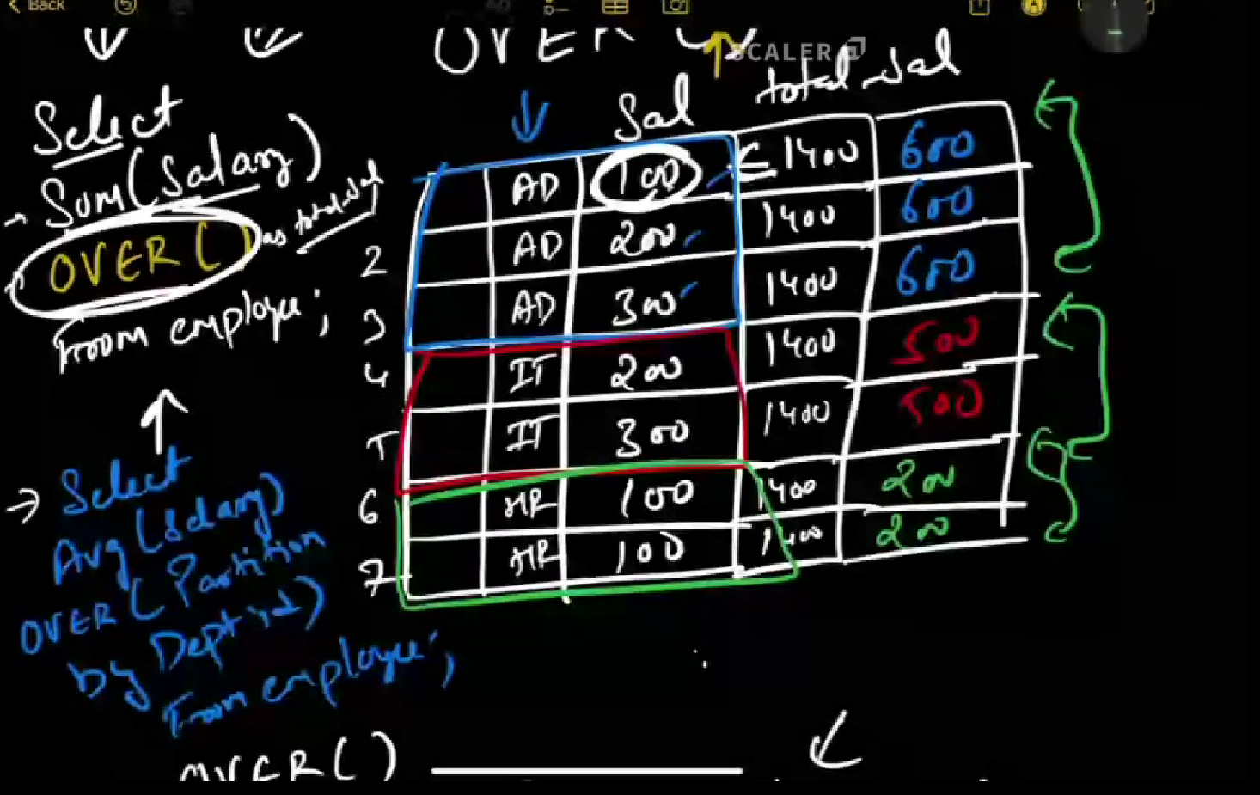

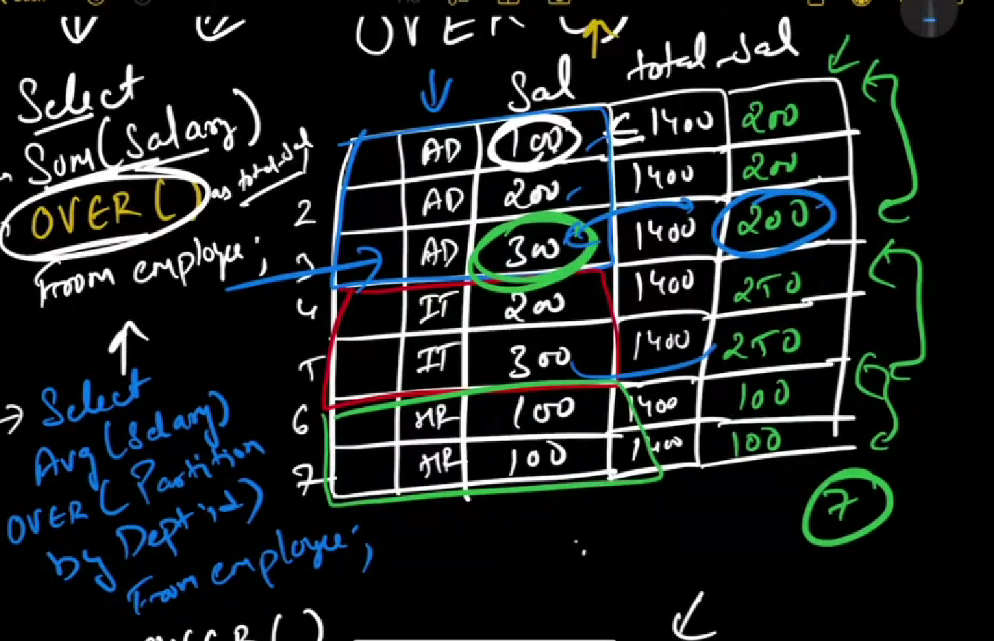

Partion by

It is way of grouping the data

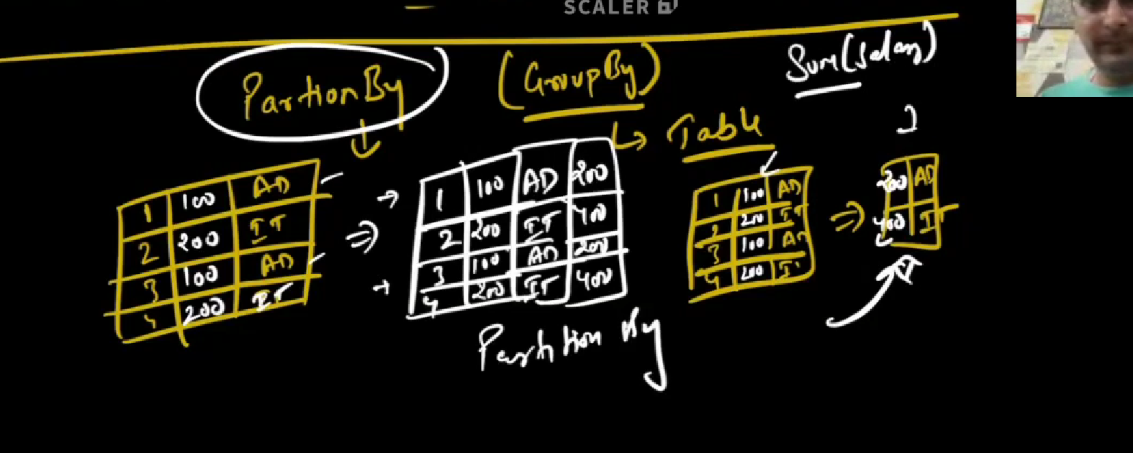

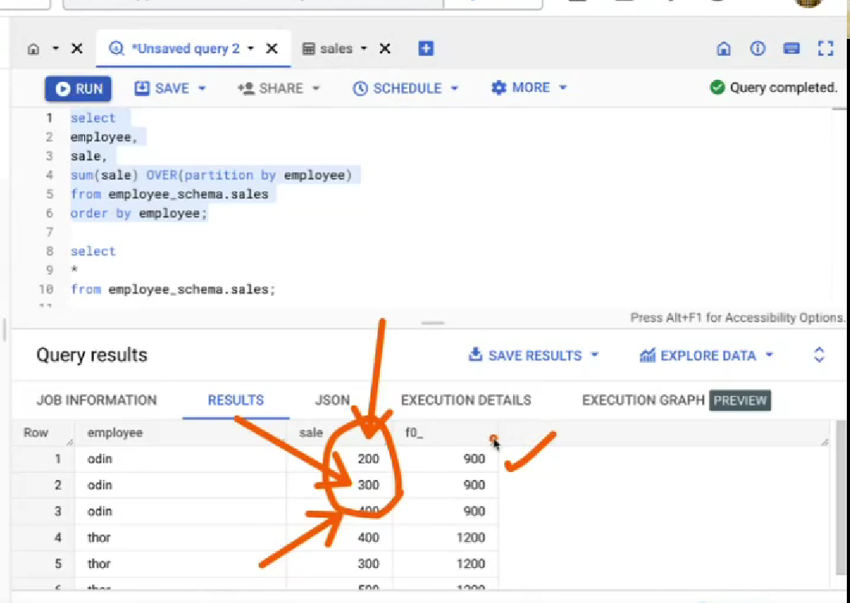

How to group data without collapsing the rows

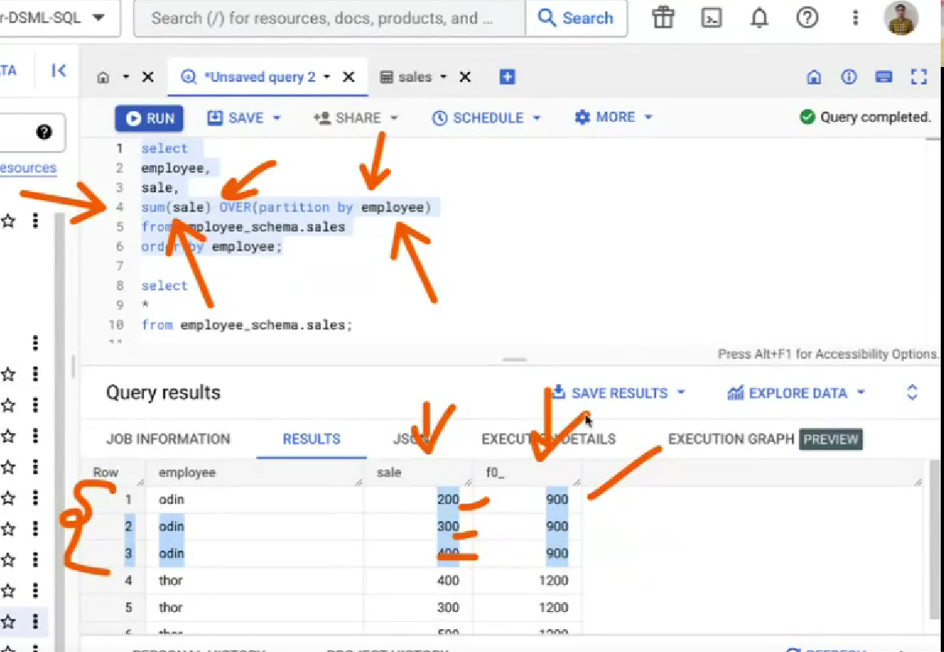

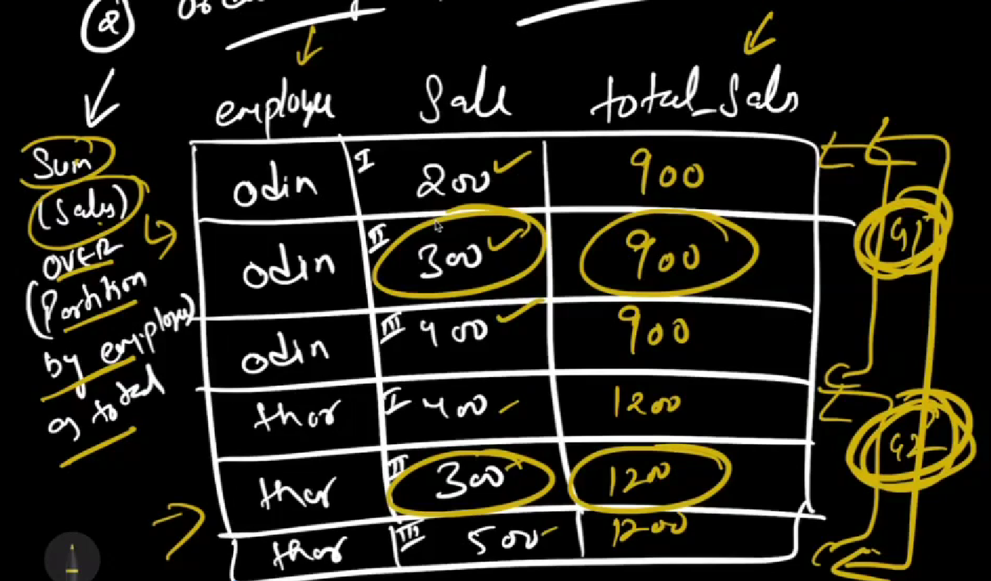

If over() is only given

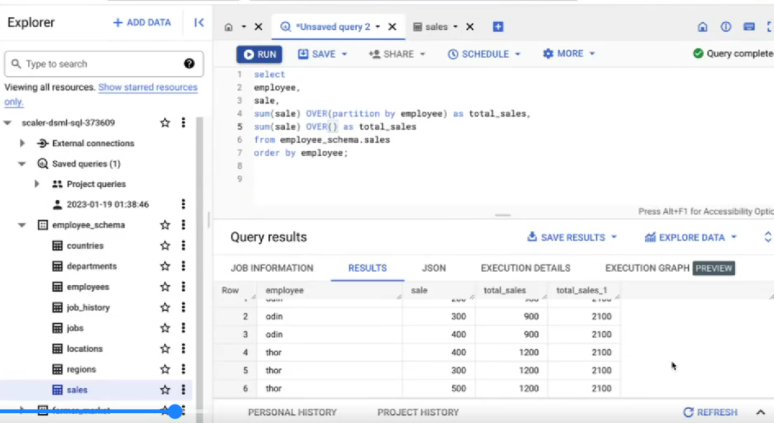

ORDER BY



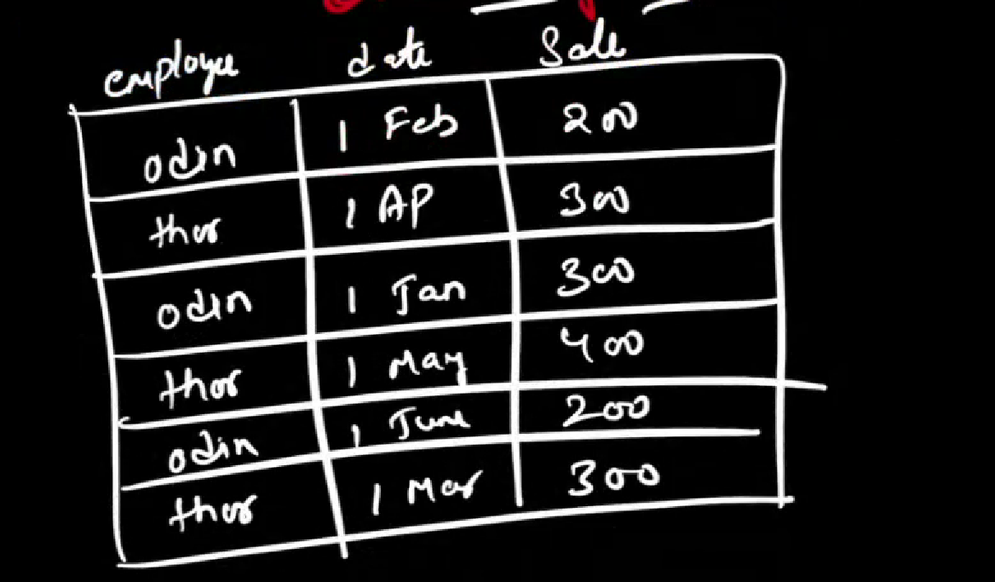

OVER clause output



Orderby date

It will not give like this instead



Order by will perform cumulative sum of rows



Last white is order by output

By default the order by will perform

**Range Between unbounded preceding and current row**

Here unbounded preceding means reach till top of the row

NOTE : order by will perform the aggregation function if its sum it will give cumulative sum.

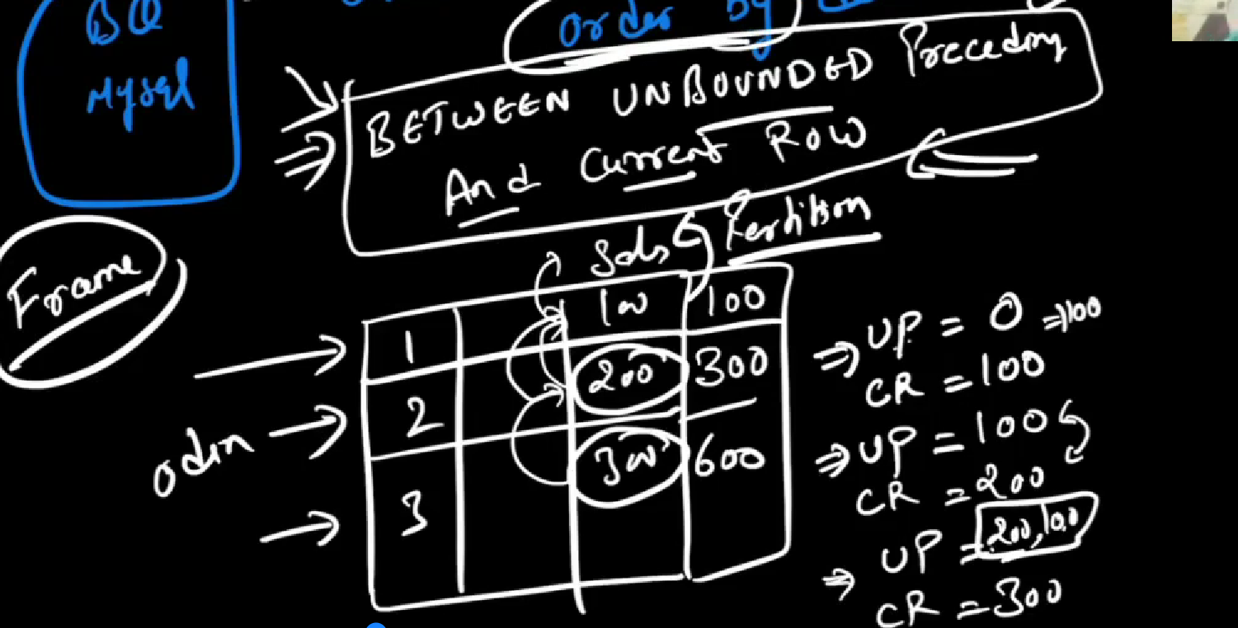

In below each row is called frame

In that table example

Unbounded preceding = UP

Current row = CR

1st row 🡪 UP = 0 and CR = 100, Now the aggregation function is SUM so person SUM of UP and CR = 0+100 🡺 100

2nd row 🡪 🡪 UP = 100,0 and CR = 100, Now the aggregation function is SUM so person (SUM of UP) + CR = (0+100) + 200 🡺 300

3rd row 🡪 🡪 UP = 200,100,0 and CR = 100, Now the aggregation function is SUM so person (SUM of UP) + CR = (200+100+0) + 300 🡺600

In a frame there are unbounded preceding, current row, unbounded following



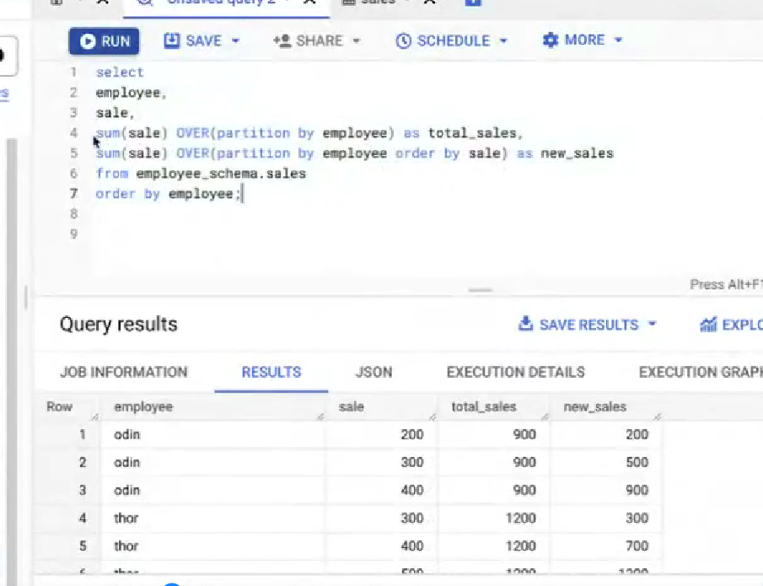

We can modify the default order by

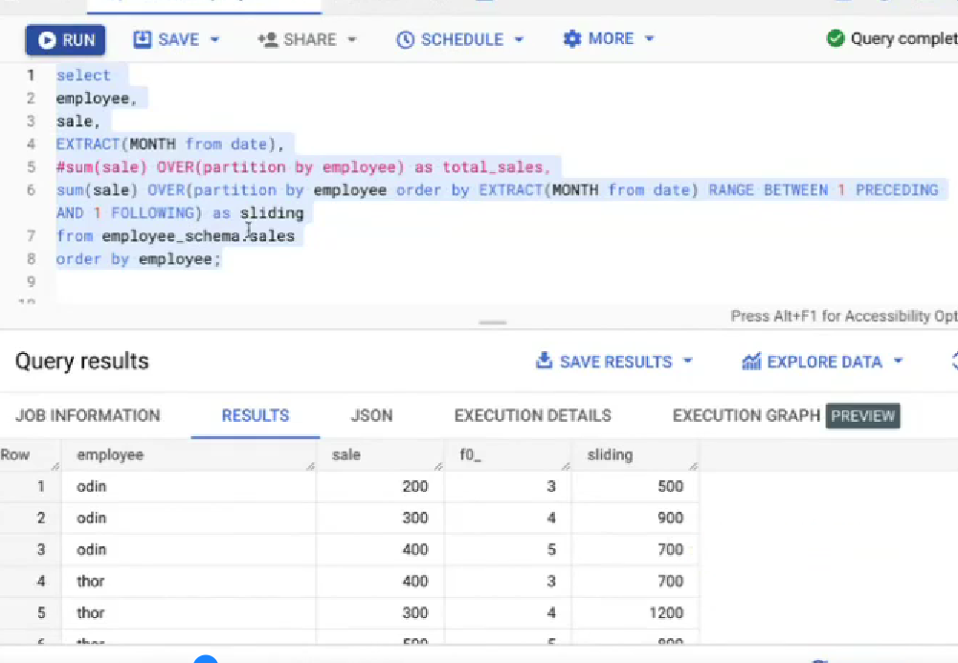

In the above example we have given RANGE 1 peceding and 1 following -> which means we need

One row up , current row and one row down

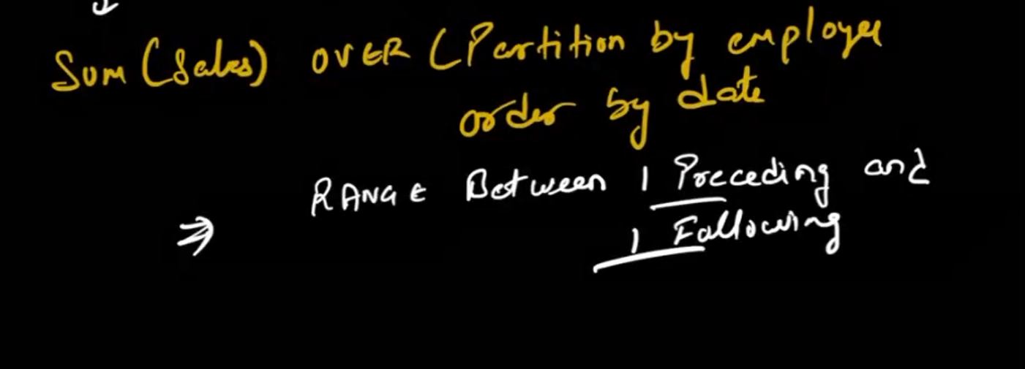

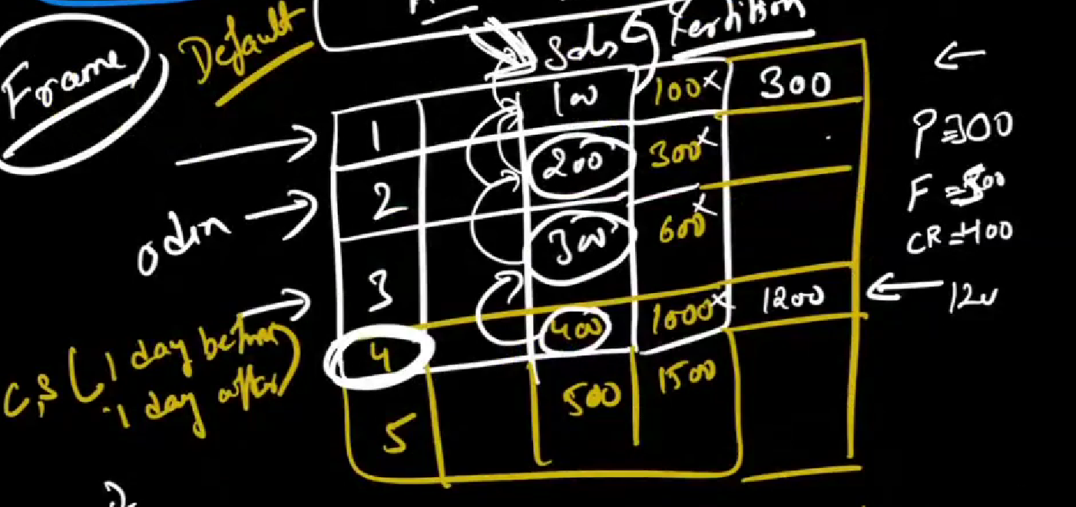

Example :



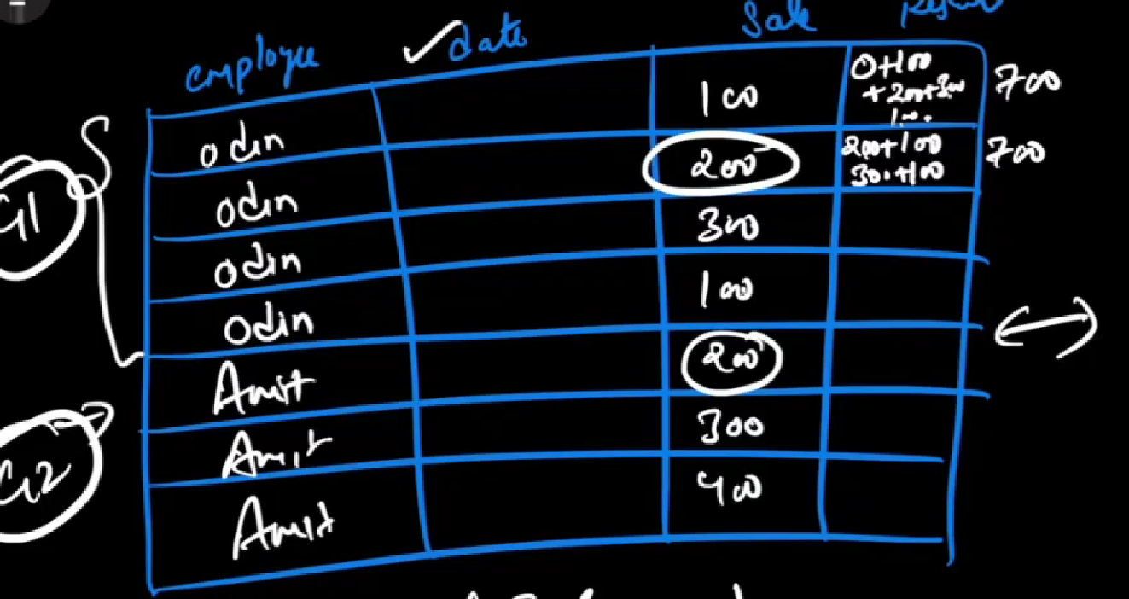

In order by Range

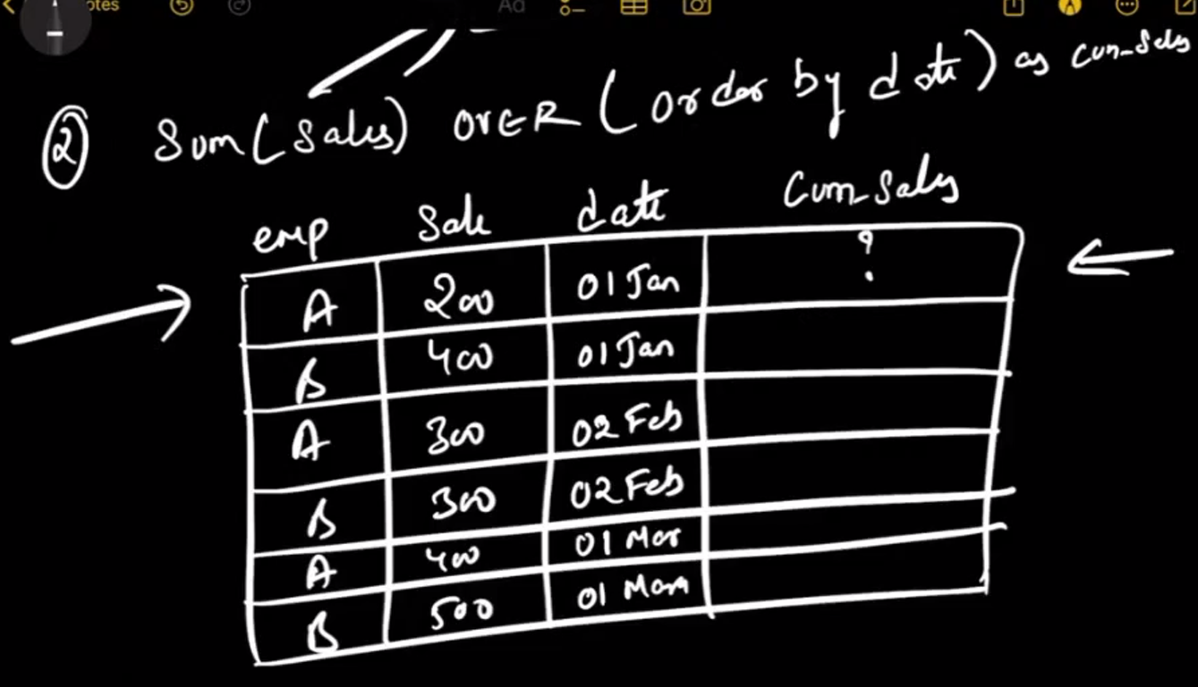

Here in order by it will have default value has

**Range Between unbounded preceding and current row**

In above order by the dates are similar in 1 and 2 row. RANGE lt has major issue

behave like if there are duplicate values it will comsider has single row (200+400) 🡪 600

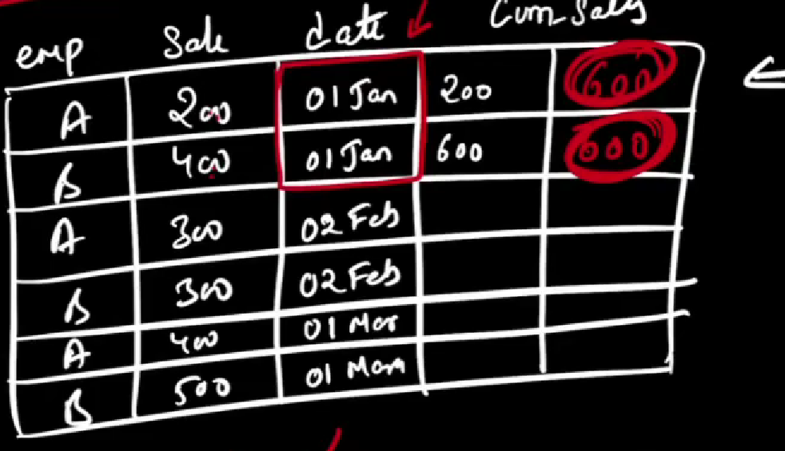

THE thing we can achieve by ROWS instead of RANGE it will give cumulative values

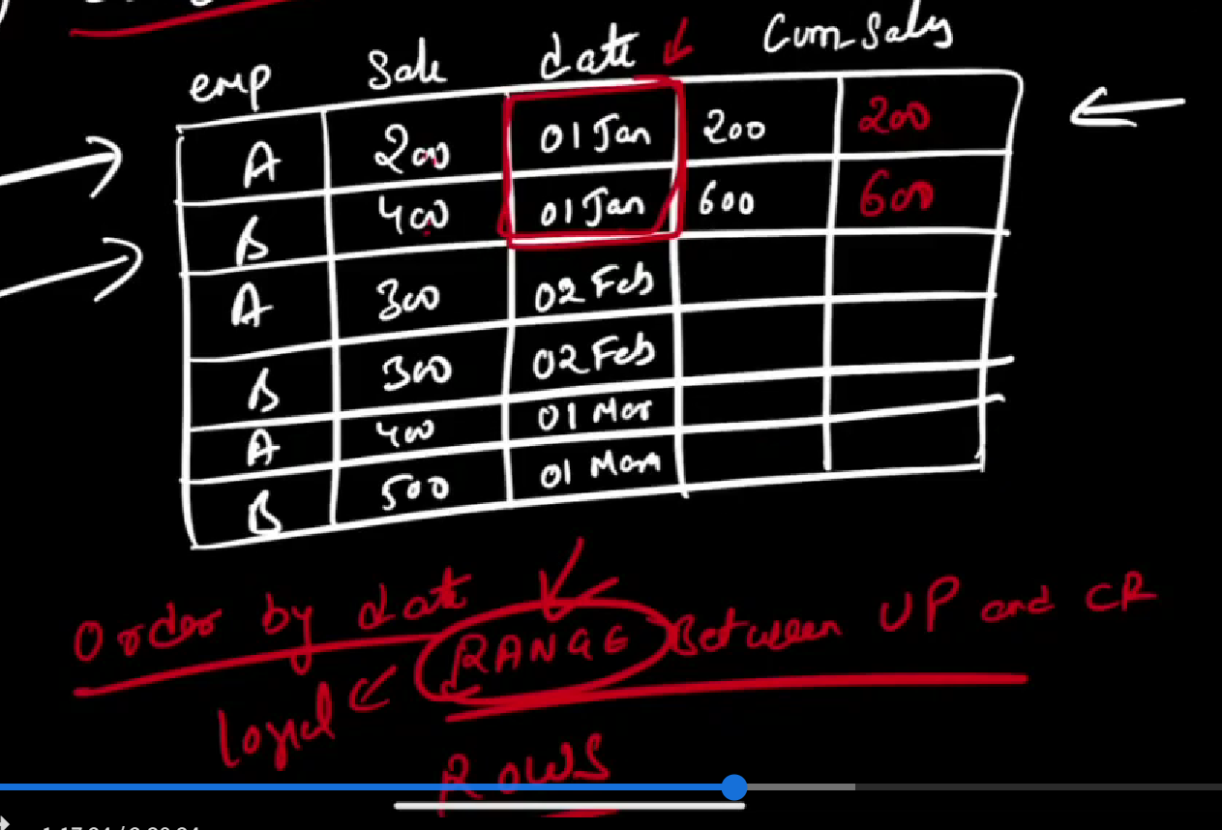

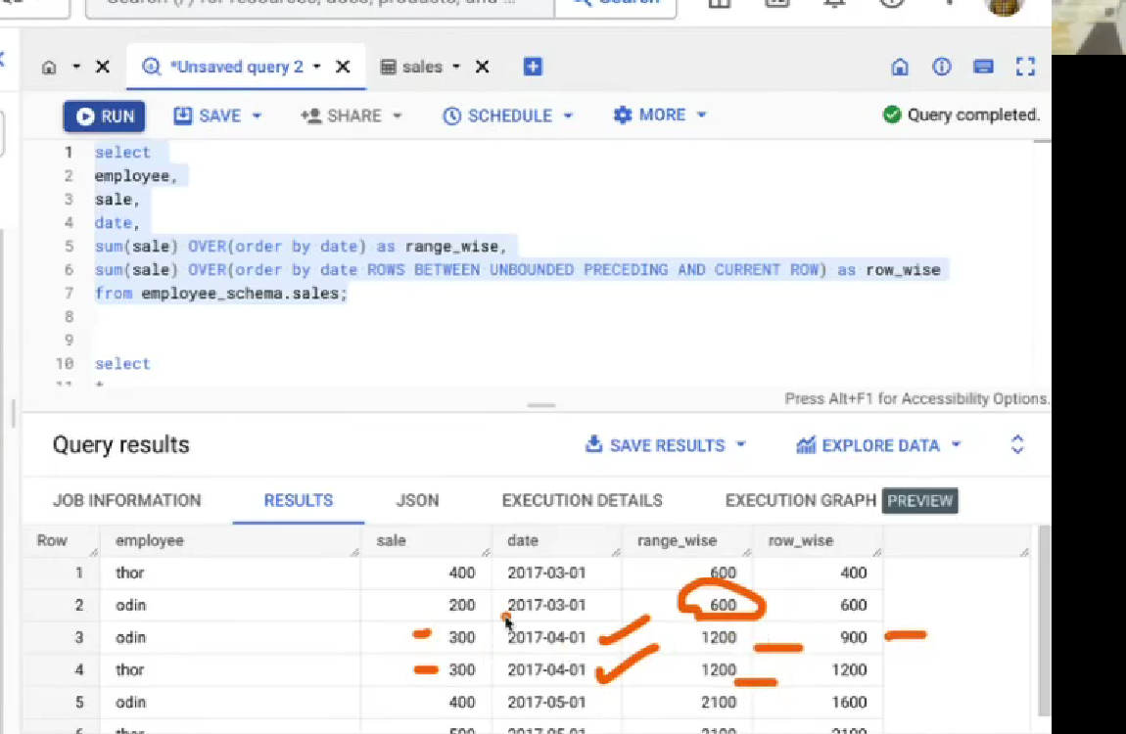

ANALYTICAL FUNCTION

1. Row_number - it will give number of rows and assigh the idx to each row. It will include duplicate values

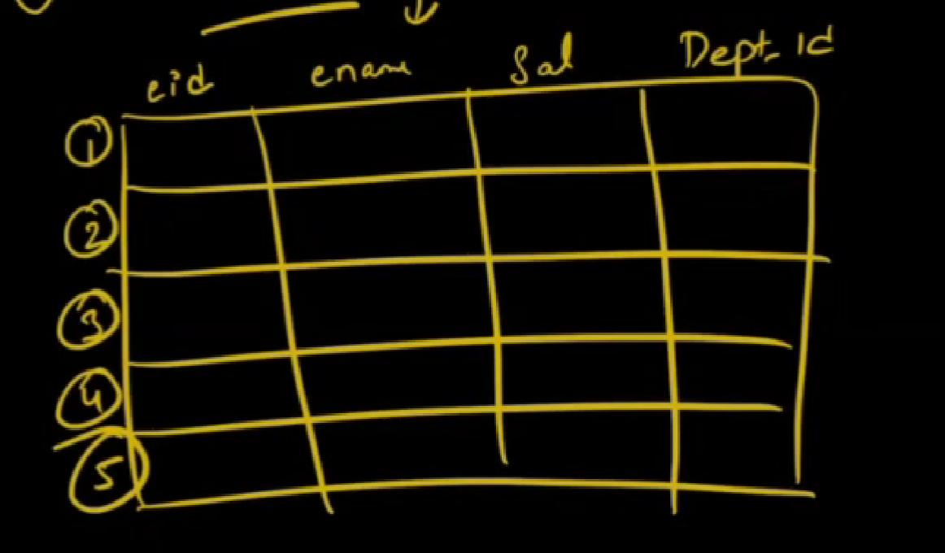

Example :

Syntax :

Select

Row_number() over( partion by … order by …)

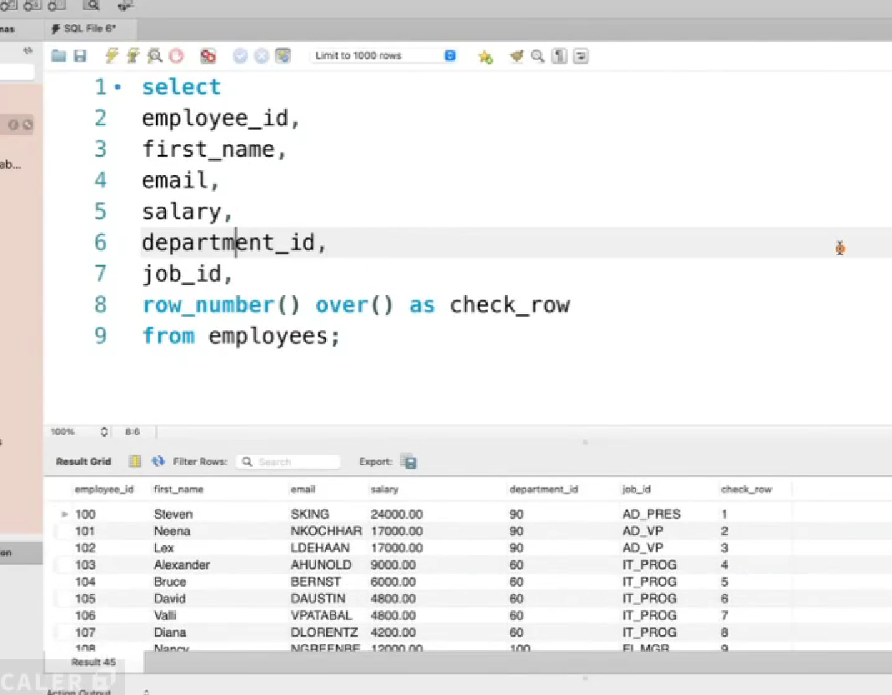

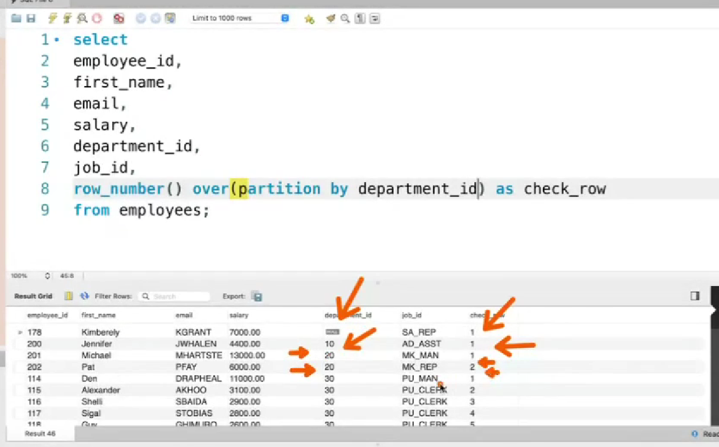

Example :

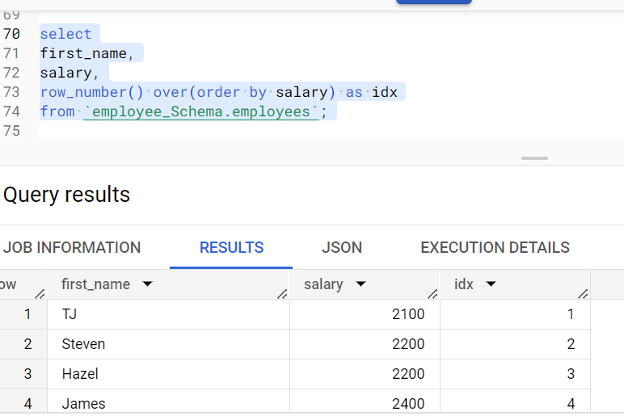

Above there are duplicate rows but also it will consider it and it will count . Here 2nd and third row have same salary but the naming the row it will increment.

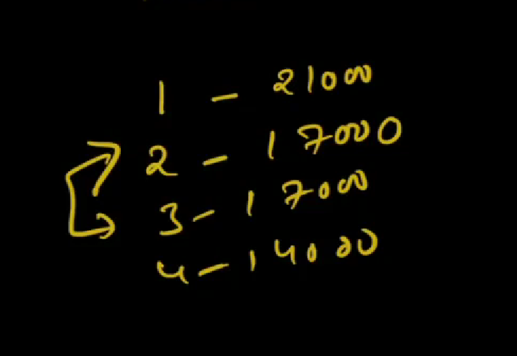

1. RANK – here if there are duplicates it will name then with same number.

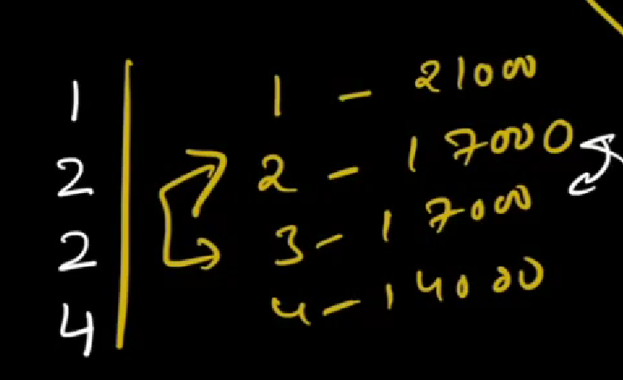

Here row 2 and 3 have same numbers so its naming number with same value. But for next row it will skip 3 since that space is already occupied and give 4

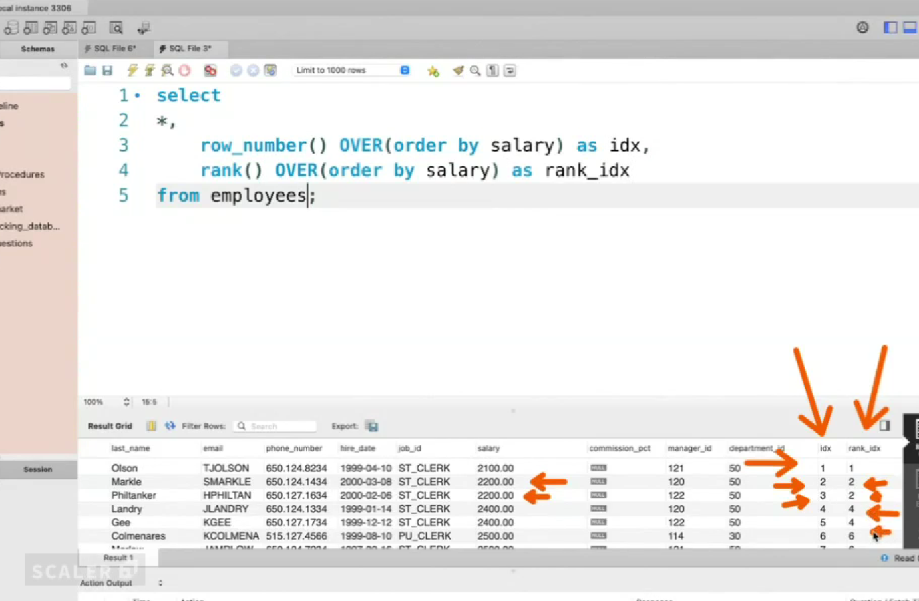

If we don’t give anything in over clausethen the O/P is 1 for all row s

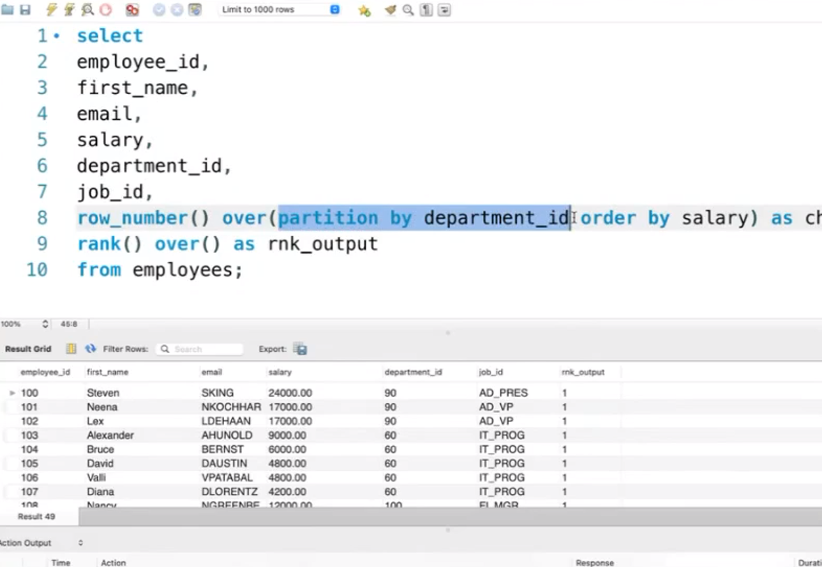 I row_number or rank we need to put order by then only we can get a functionality of those function

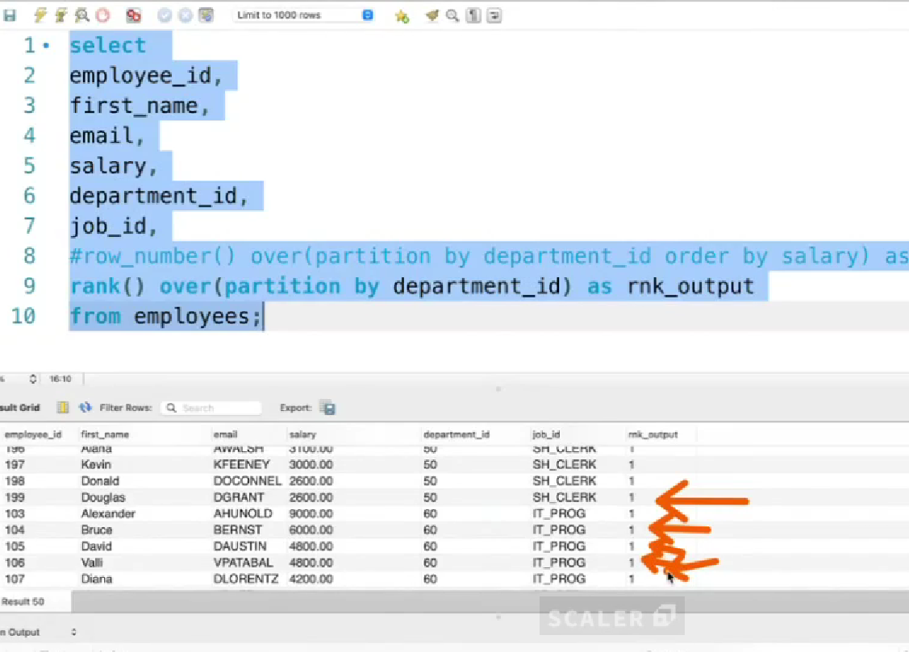

Above only partion is given so it will just give 1 for al rows

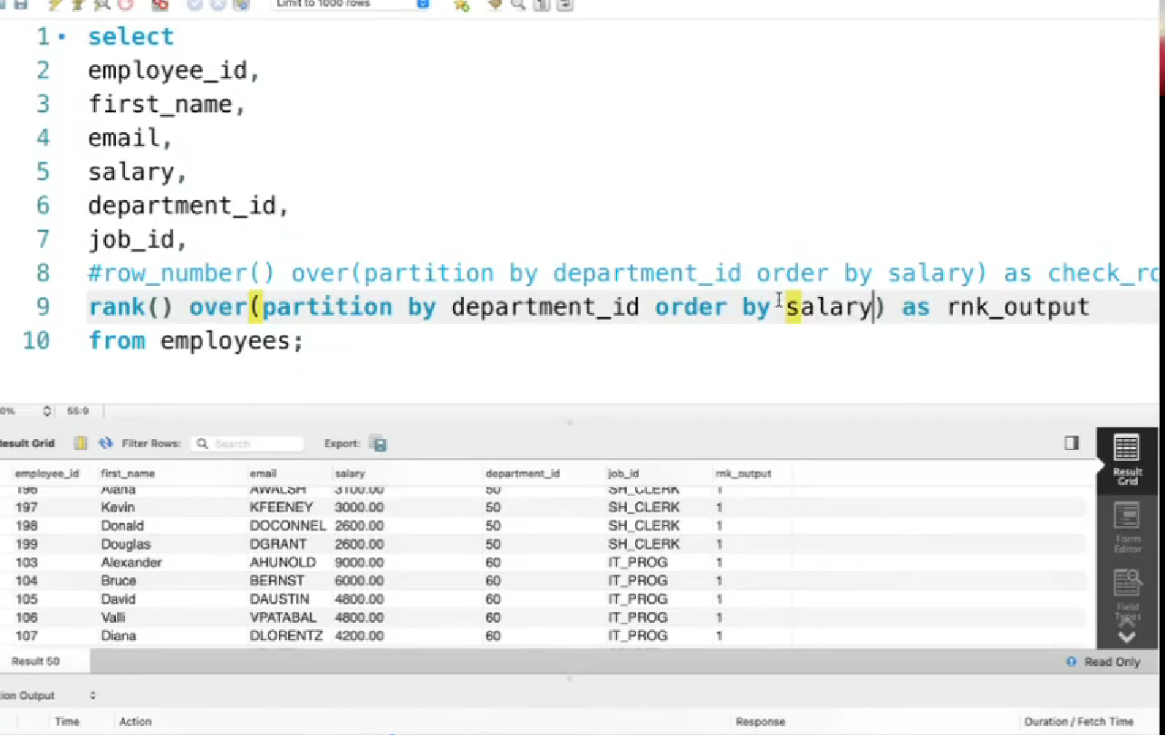

Above o/p is not takem screenshot

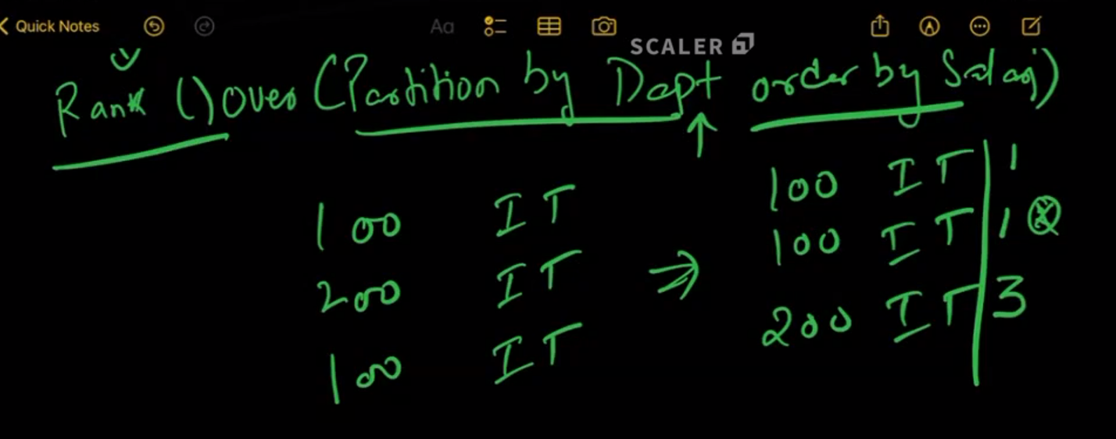

1. DENSE_RANK

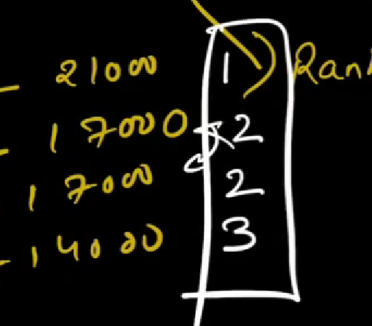

Here it will name duplicate with same number.

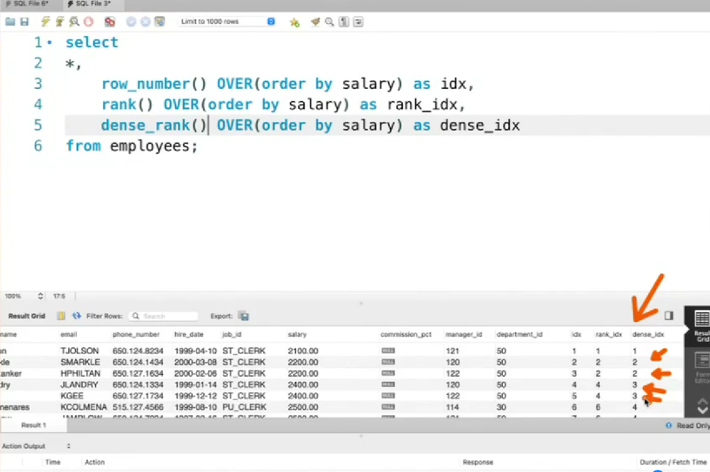

select

first_name,

salary,

row_number() over(order by salary desc) as idx,

rank() over(order by salary desc) as rank_idx,

dense_rank() over(order by salary desc) as dense_rank_idx

from `employee_Schema.employees`

order by dense_rank_idx,rank_idx,idx;

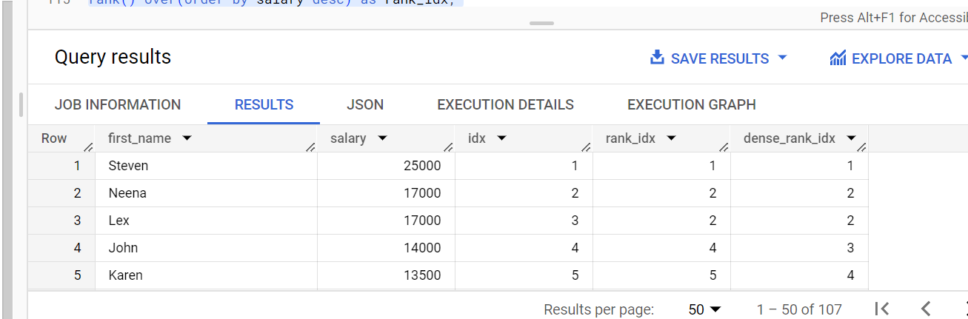

in bigquery here we need to order since in row_number() it has orders by desc so next if we put again its getting confused

Question

1. JOIN these 2 table nth is common between 2 tables

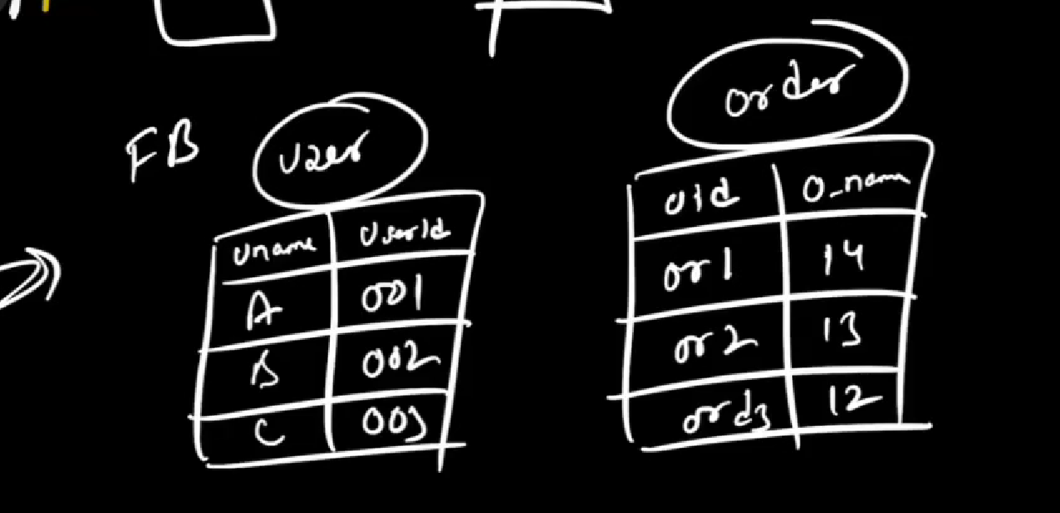

Here one way approach is add row number to both table

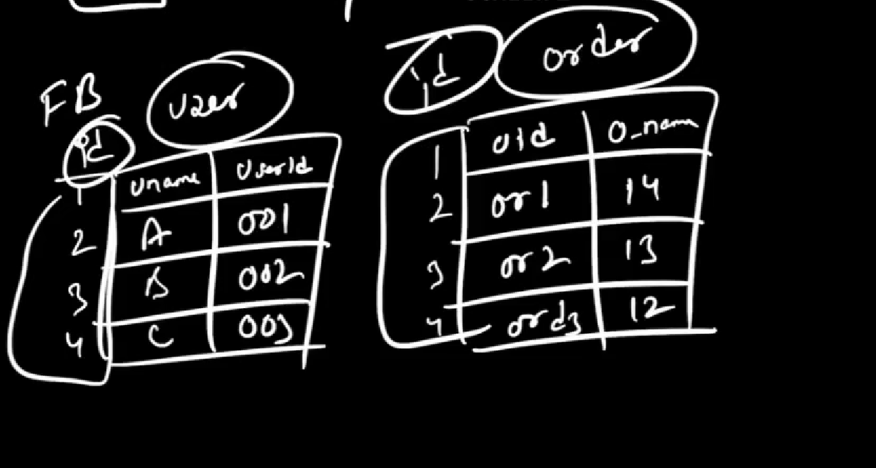

And join 2 table using id

Assighment in analytical section

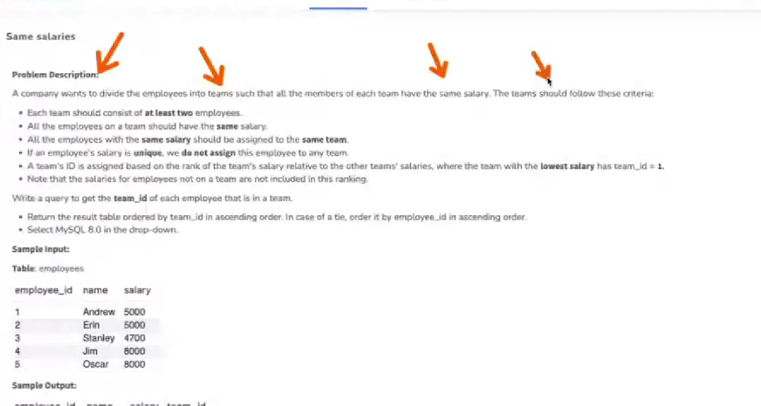

Ntile function

It is a buckting function. Its main object to classify a data into some relevant bucktes

It will distribute you data into fix number of buckets

Based on condition its disturbing and we can filter and get one bucket data

Synax :

ntile (no of buckets need to be grouped ) over(partition by .. order by )

Example : group the 10 records to 3 buckets

select

*,

ntile(10) over(order by job_id) as ntile_job

from `employee_Schema.employees`

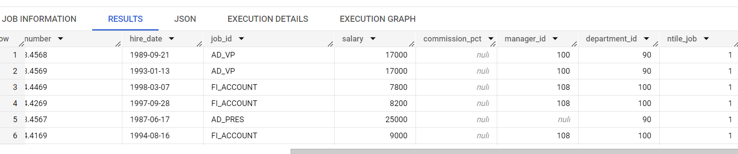

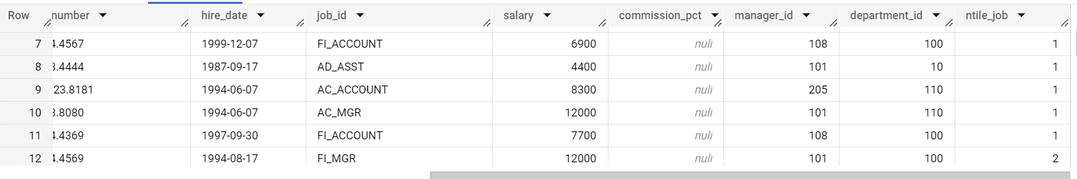

Filter based on bucket number

select * from (

select

*,

ntile(10) over(order by job_id) as ntile_job

from `employee_Schema.employees`

) where ntile_job = 2;

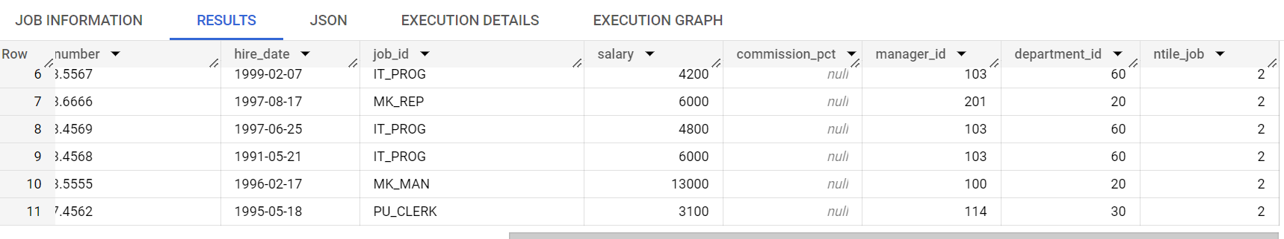

**LAG AND LEAD**

If I want to compare current with previous date

For example In prime day

Day1 120

Day 2 200

Day 3 80

In above I want to compare and get data

DAYS SALES comparison

Day1 120 0

Day 2 200 200-120 = 80

Day 3 80 80-200 =-120

For that we can use lag and lead

Lag means previous data

Lag(col,numberof_col_needtogoback, replacevalue_in_case_of_null)

Example : lag(col,1,0)

Lead- means forward data

lead(col,numberof_col_needtogofront, replacevalue_in_case_of_null)

Example : lead(col,1,0)

DAYS SALES LAG LEAD

Day1 120 Null/0 200

Day 2 200 120 80

Day 3 80 200 null/0

Example:question

Using the vendor_booth_assignments table in the farmer's market database, display each vendors booth assignment for each market_date along side their previous booth assignments

select

vendor_id,

market_date,

booth_number as current_boothnumber,

lag(booth_number , 1,0) over(partition by vendor_id order by market_date) as previous_boothnumber

from `farmer_market.vendor_booth_assignments`

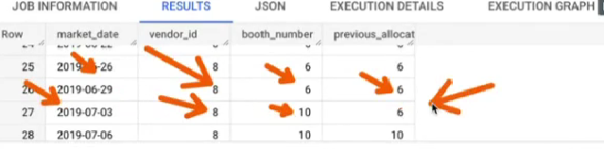

select

vendor_id,

market_date,

booth_number as current_boothnumber,

lag(booth_number , 1,0) over(partition by vendor_id order by market_date) as previous_boothnumber,

lead(booth_number , 1,0) over(partition by vendor_id order by market_date) as next_boothnumber,

lag(booth_number , 3,0) over(partition by vendor_id order by market_date) as second_previous_boothnumber,

from `farmer_market.vendor_booth_assignments`

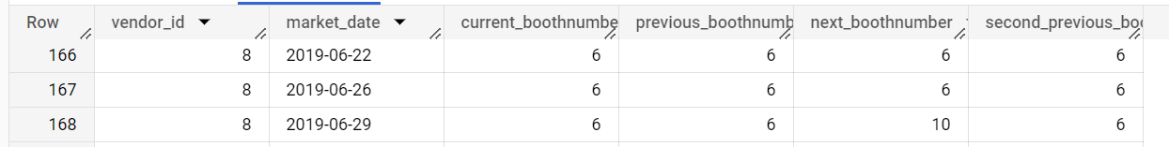

Here jump lag by 3 so for row 3 the previous allocation is 2 since its jump back by 3

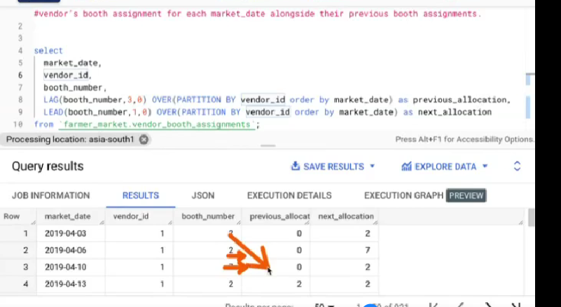

**Nth value**

It will get nth value.

Syntax : nth_value(name_ofthe_col_need to be showed , which higestvalue)

Example: nth_value(name,2) -- > 2 is the second value

-- in that employee table for IT department ID 60 Bruce is the second highest salary. So we need to display bruse besides IT department people

select

*,

nth_value(first_name,2) over(partition by job_id order by salary desc) as second_highest

from  `employee_Schema.employees`

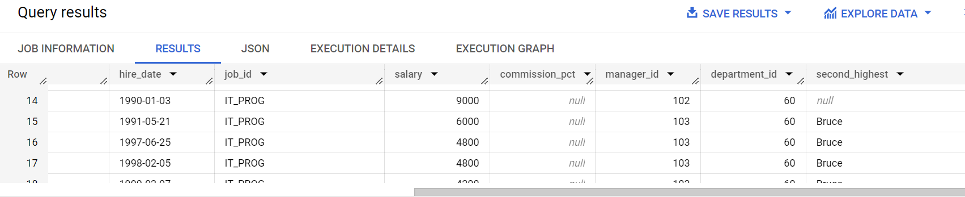

Above it has showed second highest salary person name. But for first value its cumming null

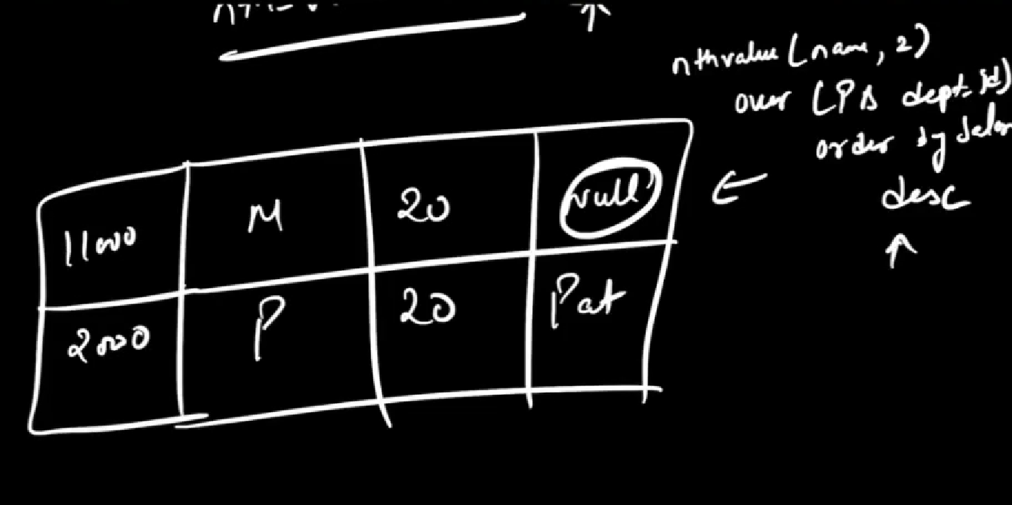

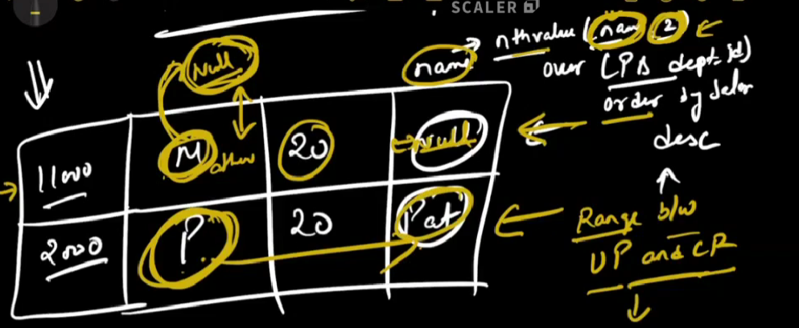

First it will order. Above data is ordered

In above example over by default have functionality “Unbounded preceding + current row “.

So when it comes to first row M. It search for preceding value its “NULL” and current row is “M”

So

NULL M

1. 1

So since there is no 2 it puts null

So it order too fill name it will fill “NULL”

In 2nd row - > up = M and CR = P and will take name P

Now need to change to “ Unbounded preceding and unbounded following “

Then now

1st row -> UP = NULL , CR = M , UF = P

NULL M P

0 1 2

Now it take second value and print P in name col

2nd row 🡪UP = M , CR = P , UF =null

M P null

1 2 3

Now it take second value and print “P” in name col

select

*,

nth_value(first_name,2) over(partition by job_id order by salary desc rows between unbounded preceding and unbounded following) as second_highest

from  `employee_Schema.employees`

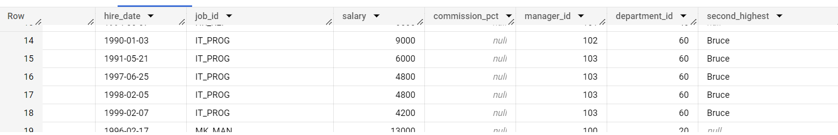

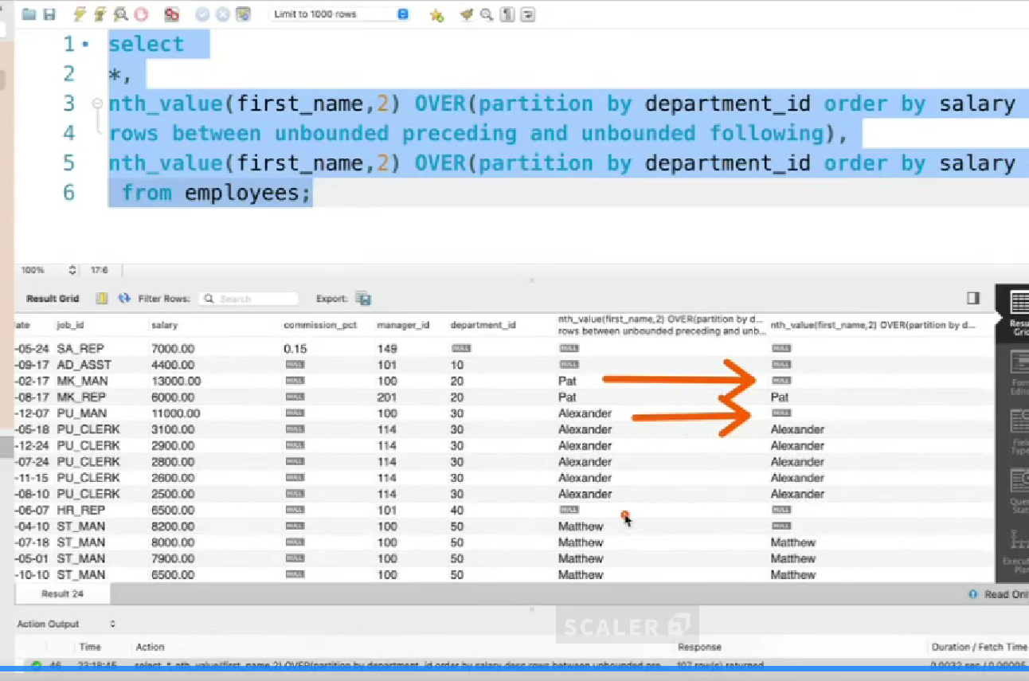

If there are duplicates in salary like 2 person have 14000 , 14000

Example

A 15000

M 14000

P 14000

Here it picks random so we can modify our code my order by salary,empid desc . Here I will pick one row based on desc empid

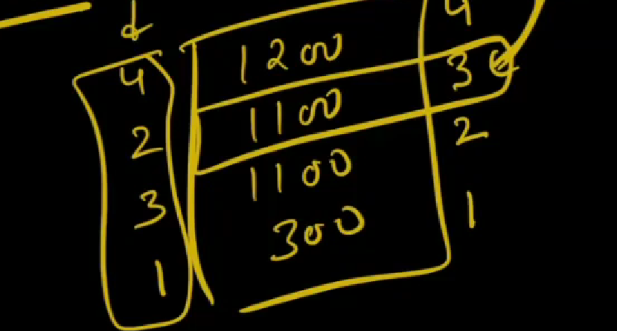

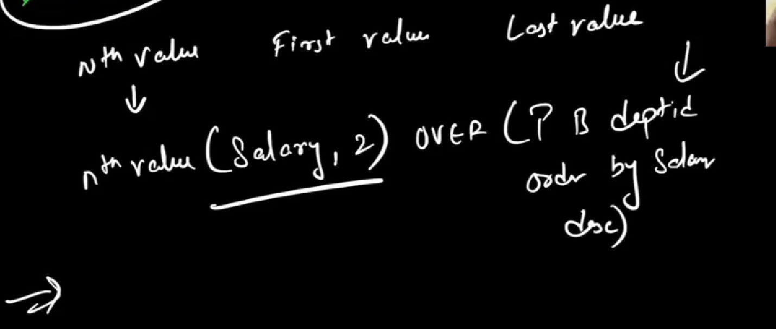

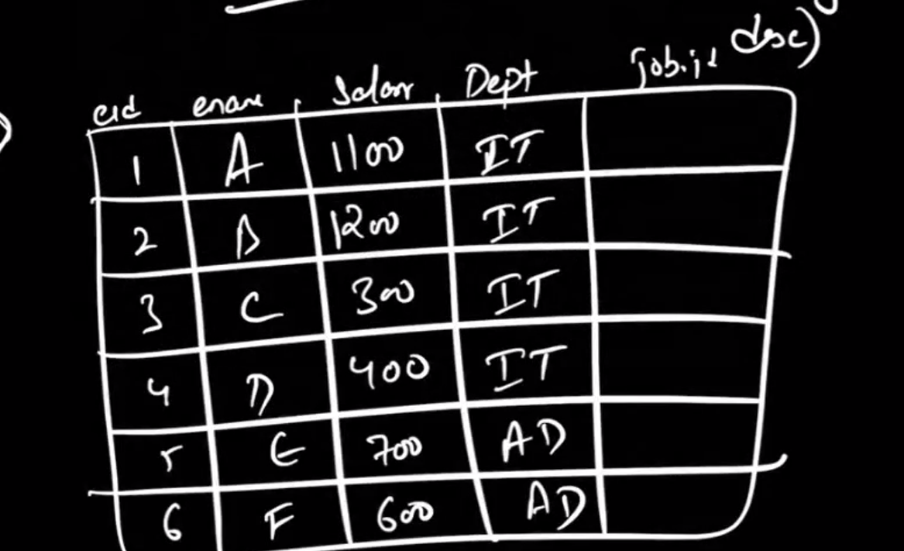

I need to show the second highest name beside each row

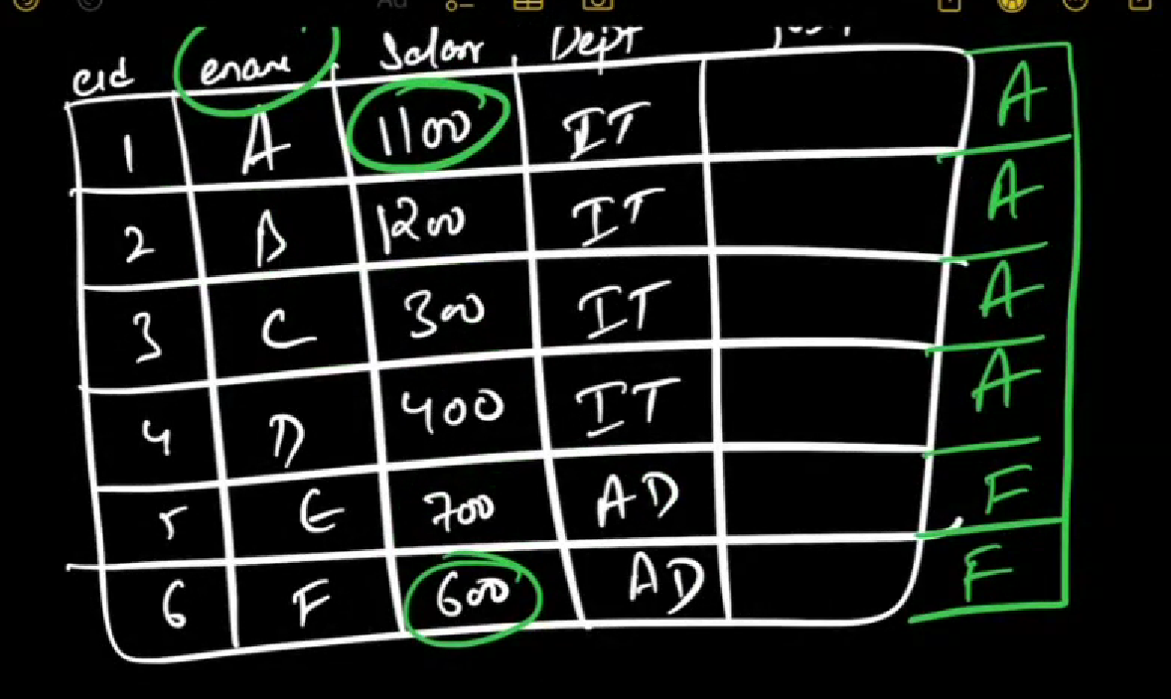

Partiotion by

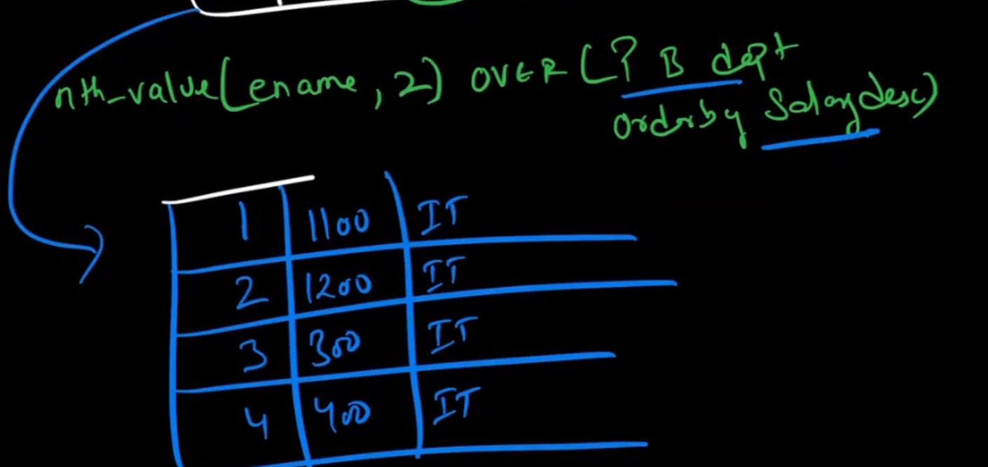

Order by salary

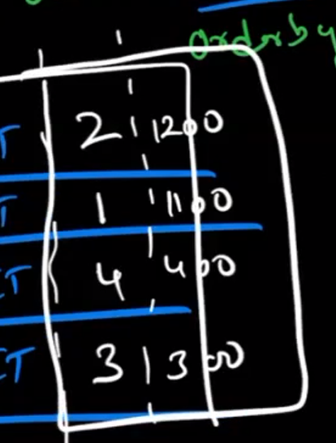

**First_value**

To get the first value either we can use nth_value(name,1) or first_value function

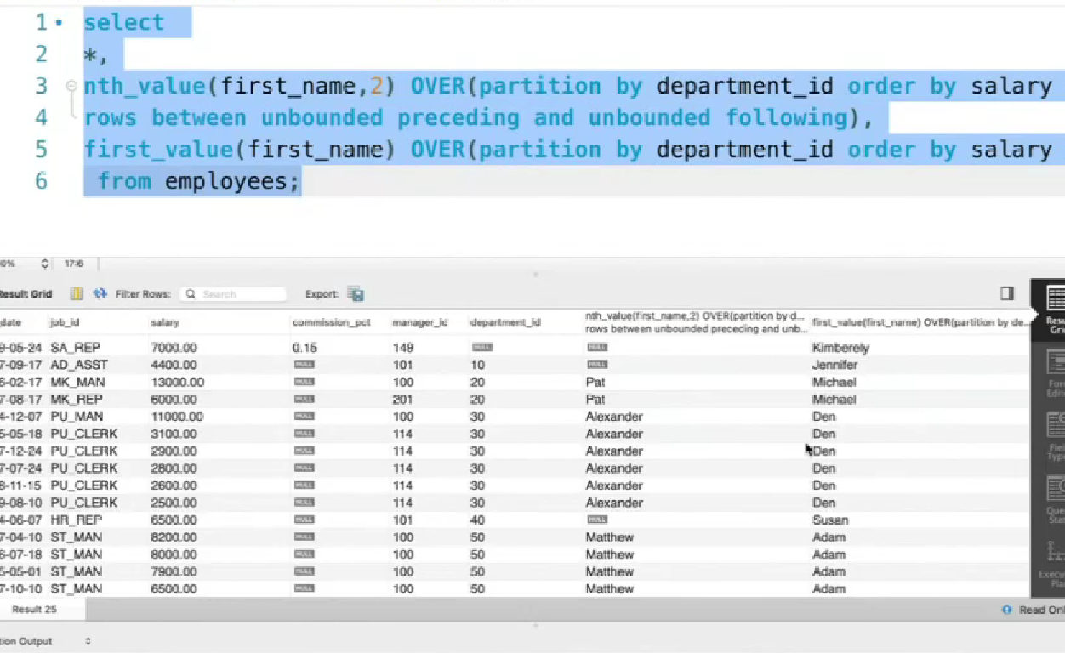

ASSGHNMENT

FIRST DAY JOB

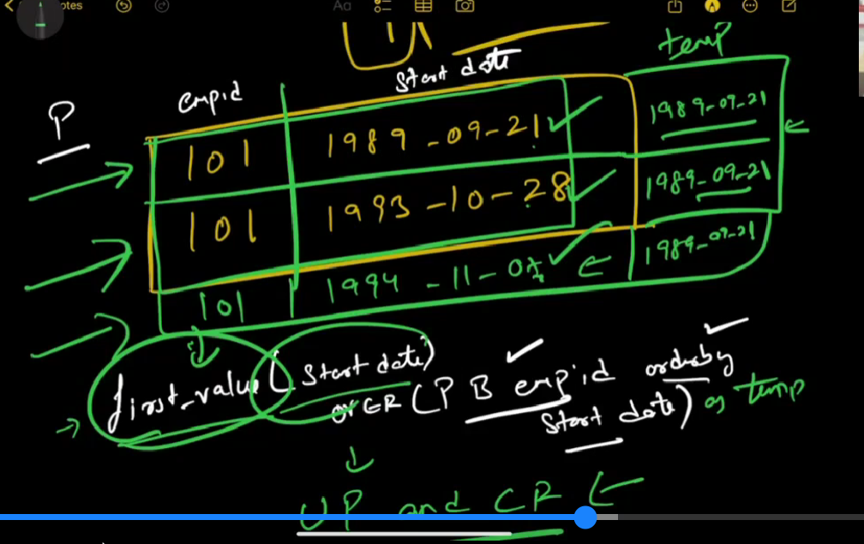

TODO : WINniNG STREAK

First we have to do player_rank

rank() over(partition by player_id,result order by match_day) as streak1,

here it will partion then order by date and assign rank refer below screenshot

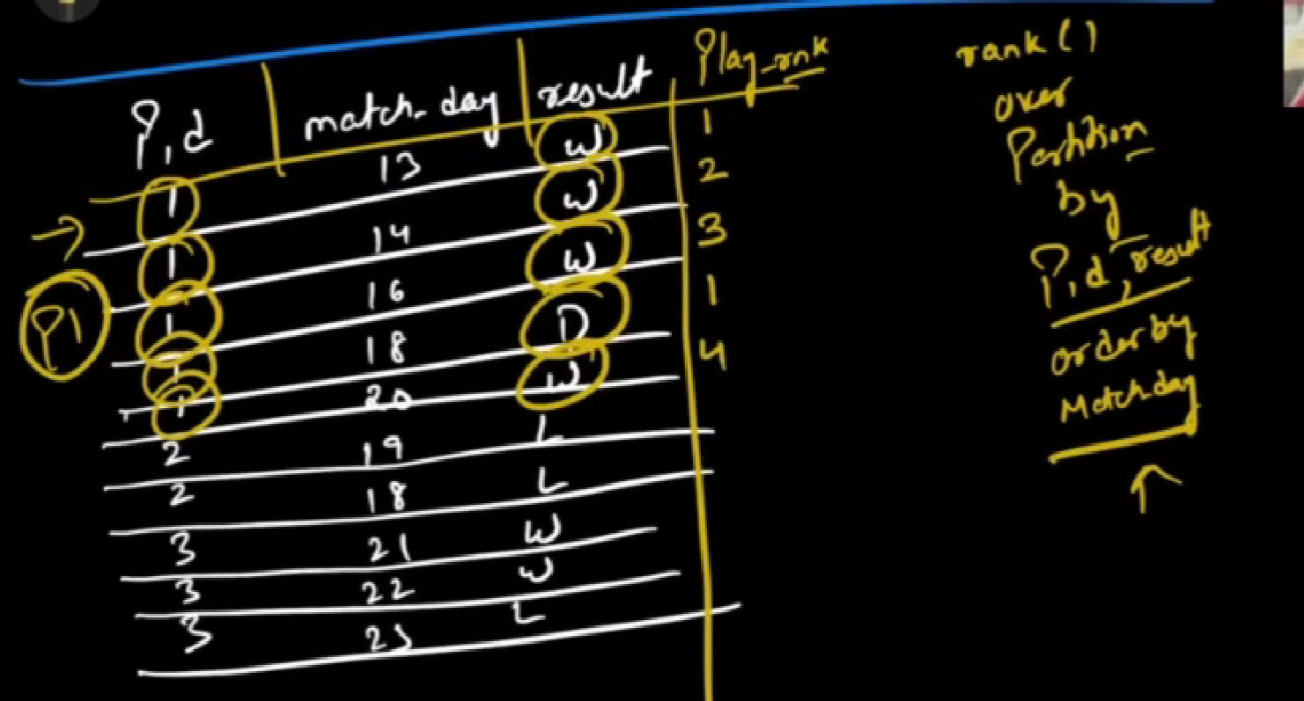

If we put only partition by it will give 1 for all so use order by

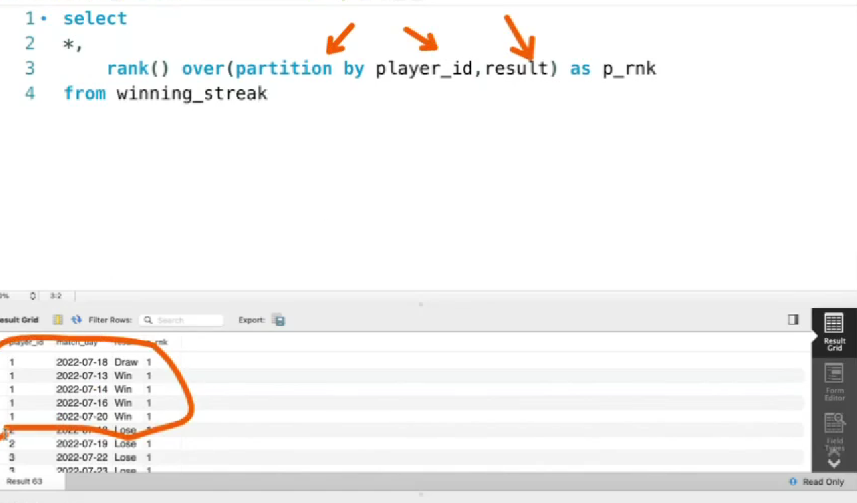

With order by

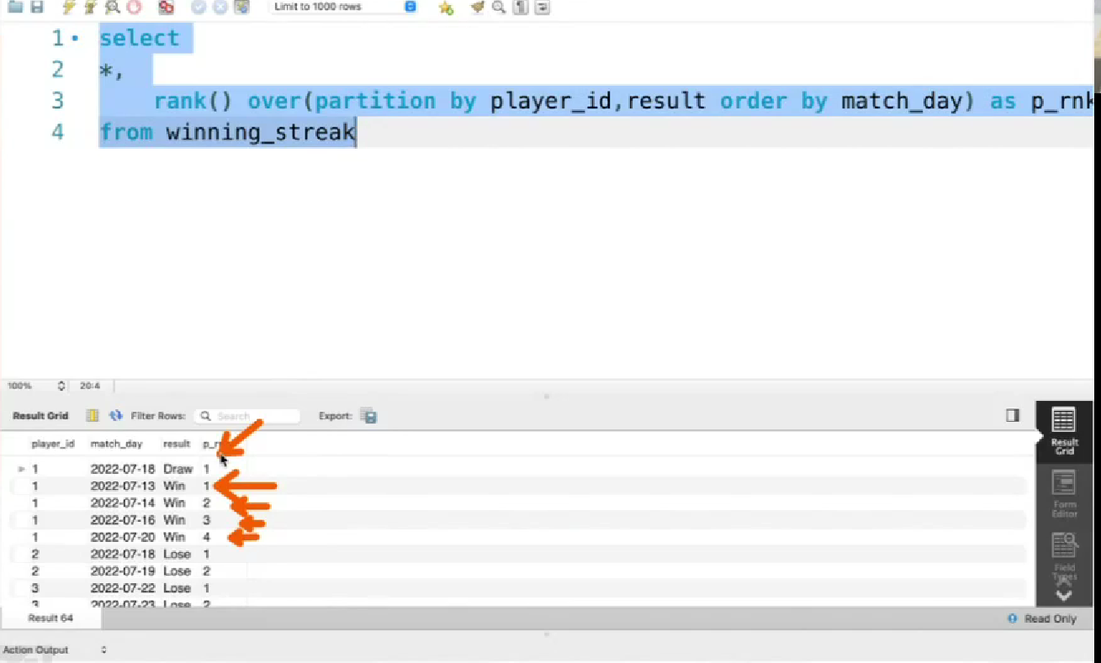

Player_rank means we will get the the data the player has won. Here winning streak is captured on player_rank

Then next condition is

rank() over(partition by player_id order by match_day) as streak2

this condition to check how much match he played

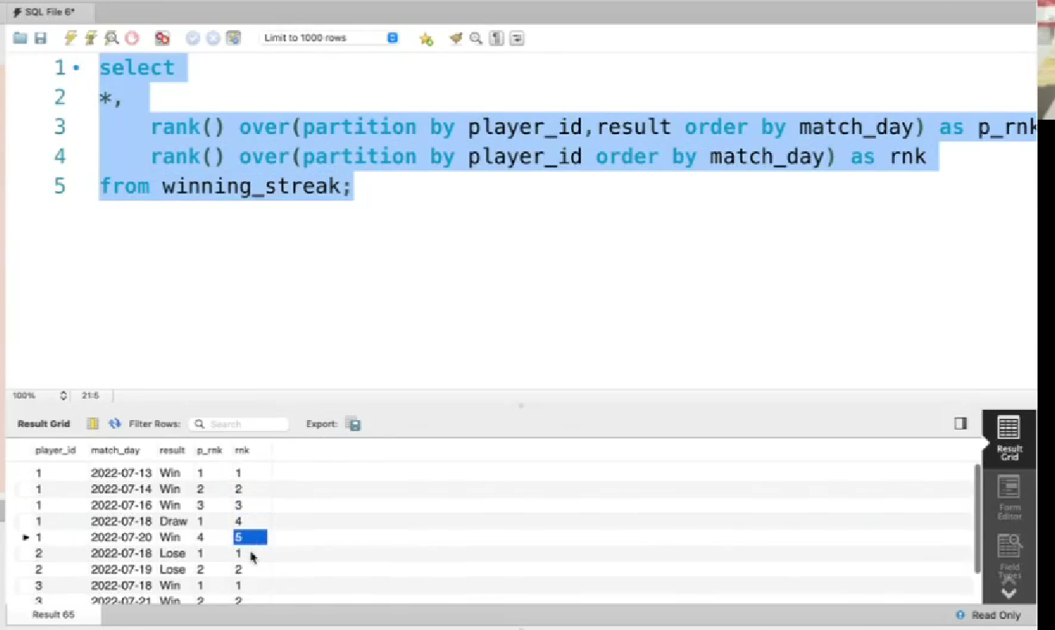

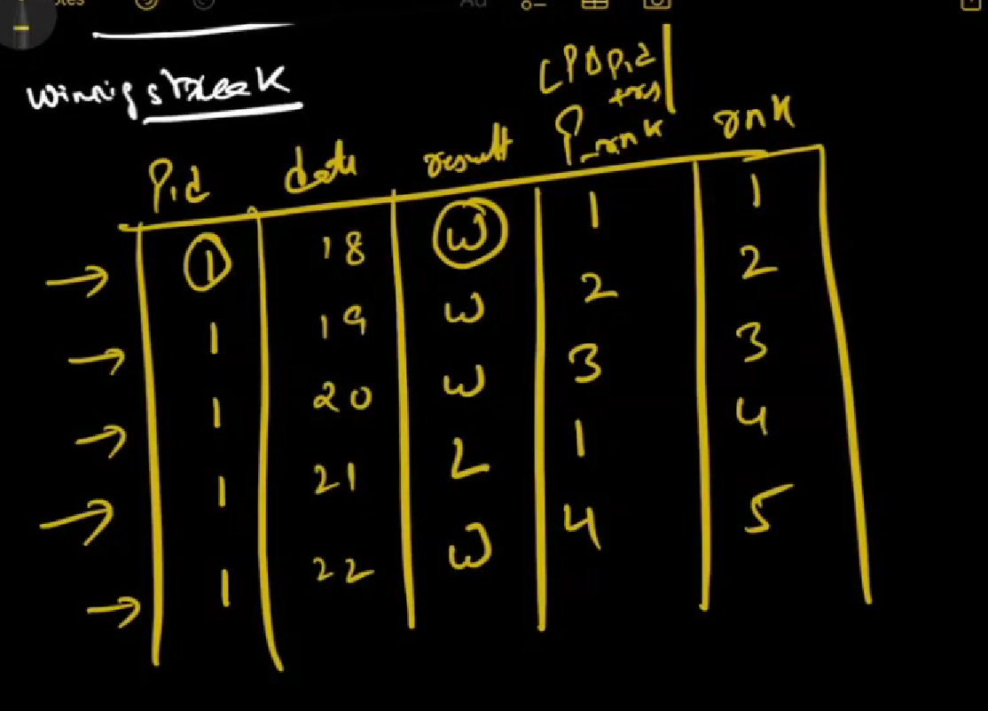

Now if we extend for player 1

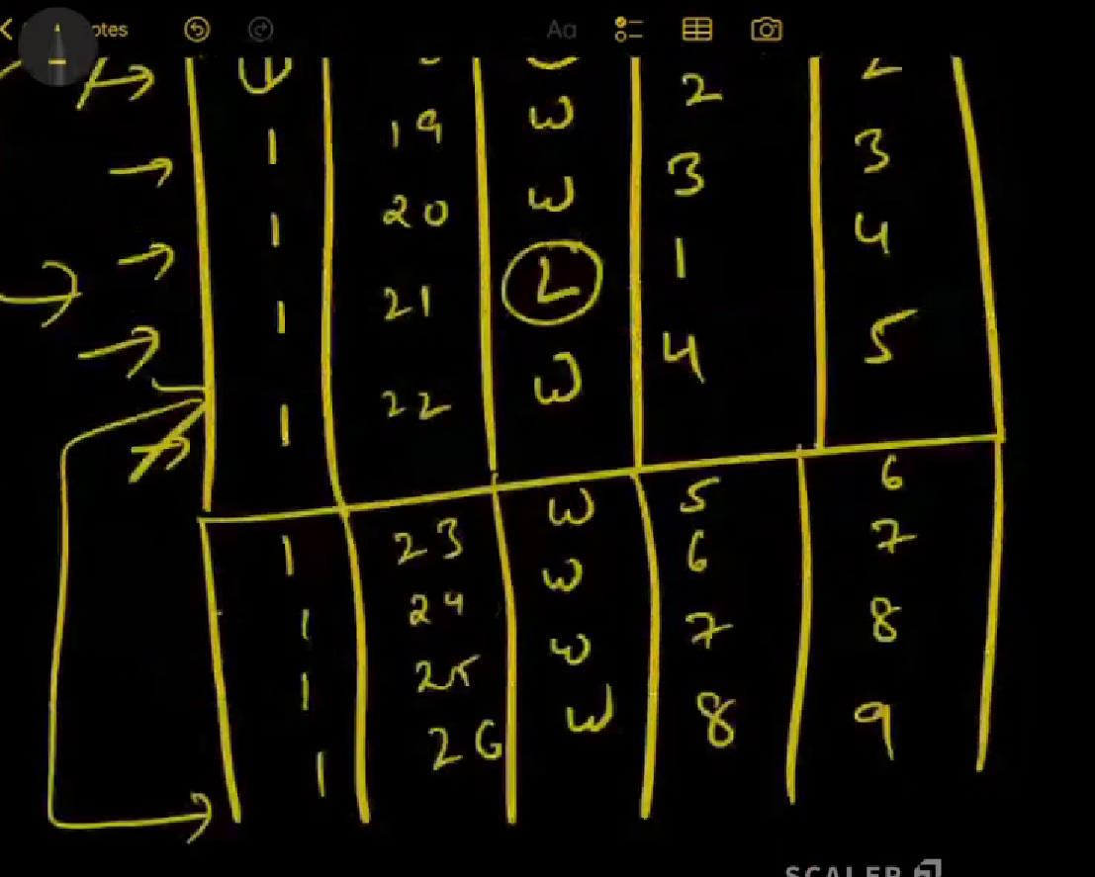

Here second part is logest winning streak

SELECT player_id , (streak2-streak1) as diff, count(streak2-streak1) as cnt FROM

(

select player_id,result,

rank() over(partition by player_id,result order by match_day) as streak1,

rank() over(partition by player_id order by match_day) as streak2

from matches

) t1

* Now on top of that we should do difference. Below screenshot the last column is difference
* Count the difference example : count(0) = 3, count(3) = 1 __> this is not not more than one so ignore

Count(1) = 5

In this 5 is logest streak

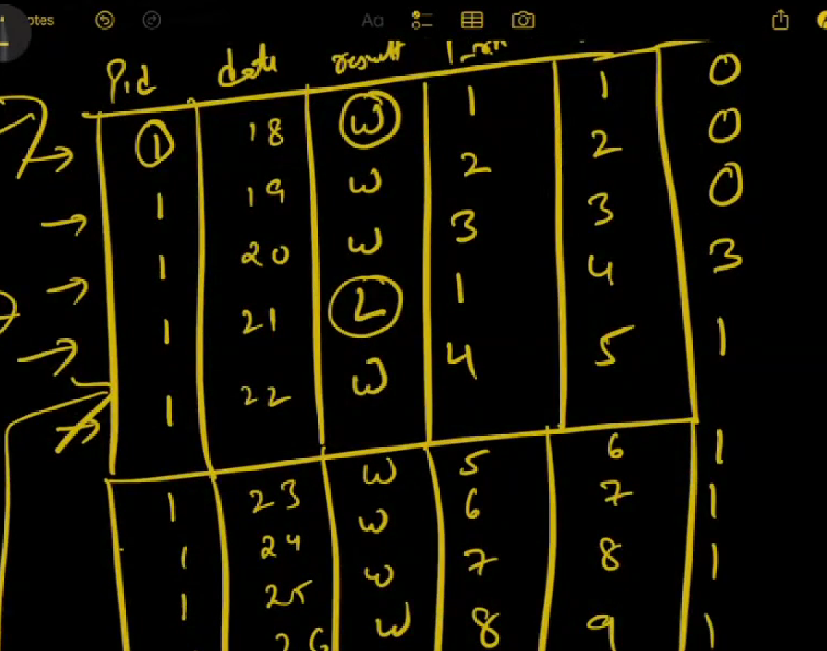

COUNT

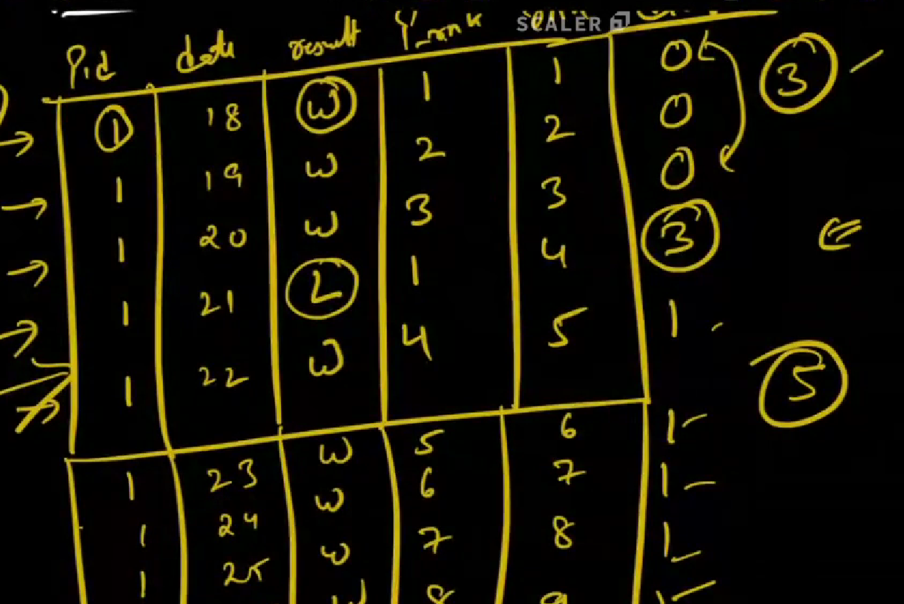

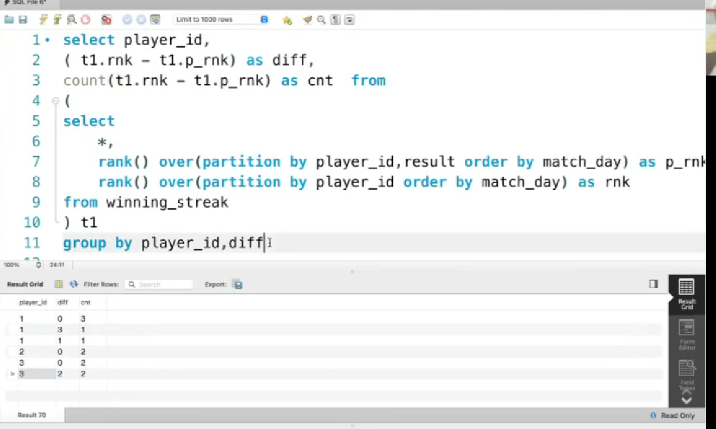

ACTIVITY Participants

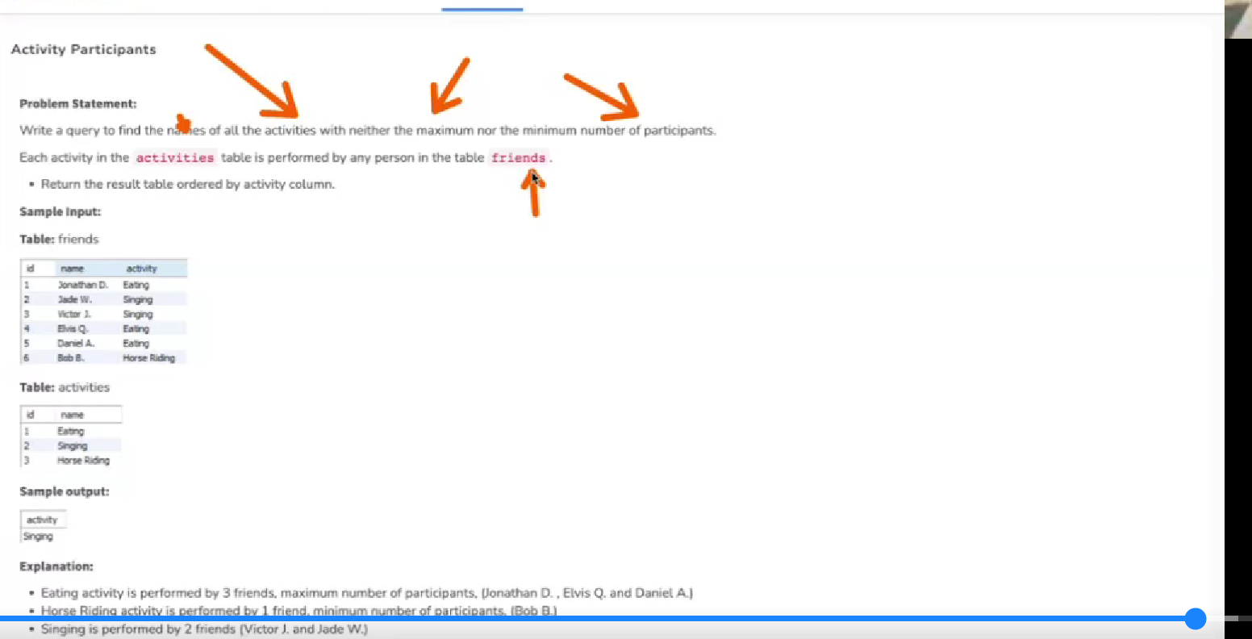

Return the activity which is either max or min

Activities table

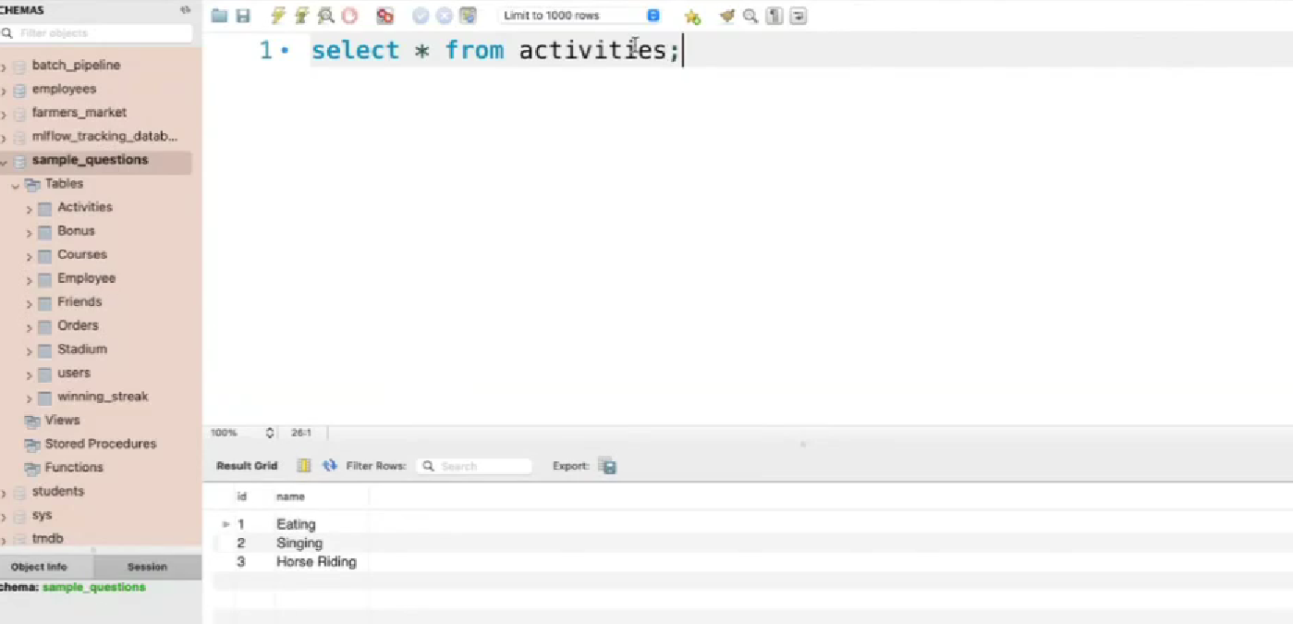

Friends table :

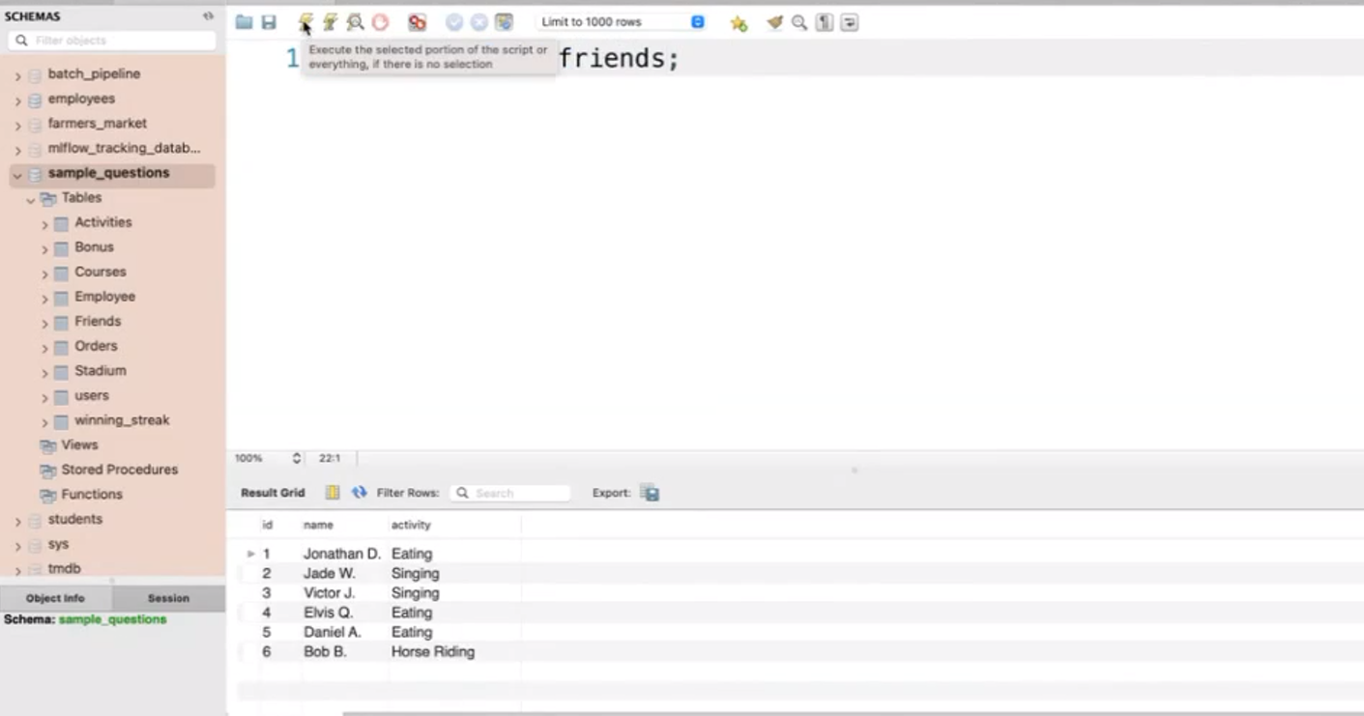

Apply group by and check

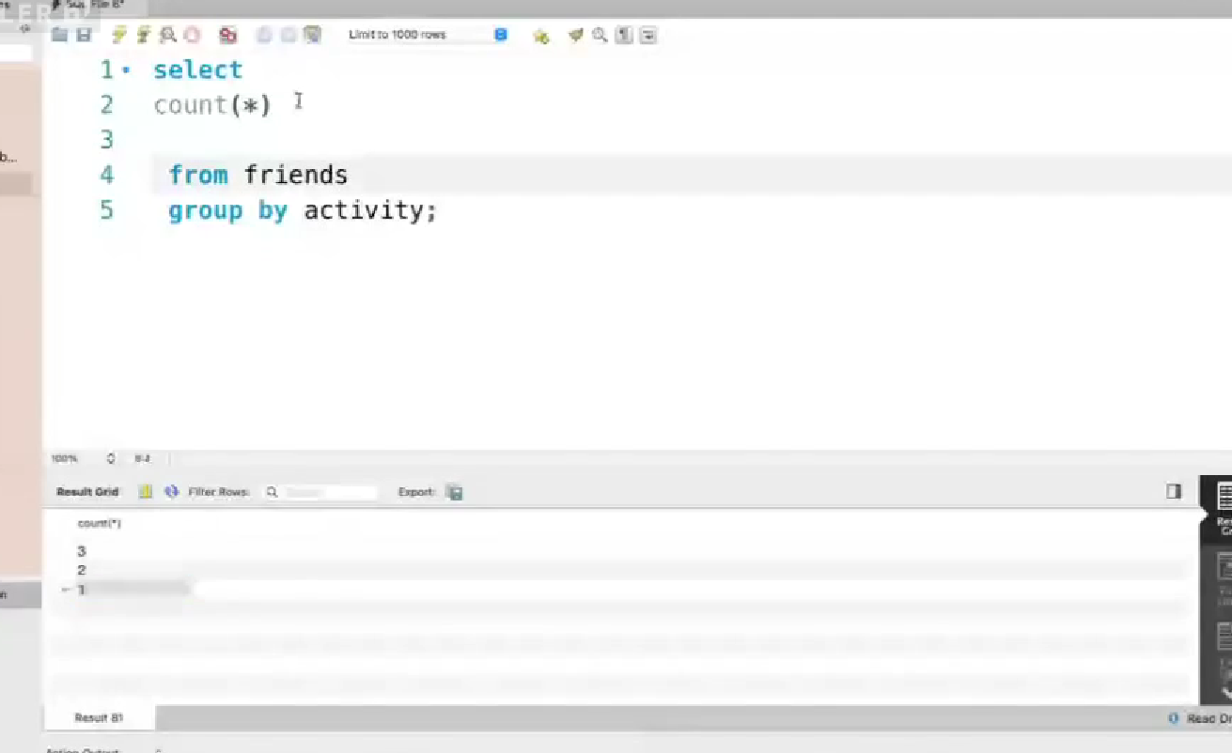

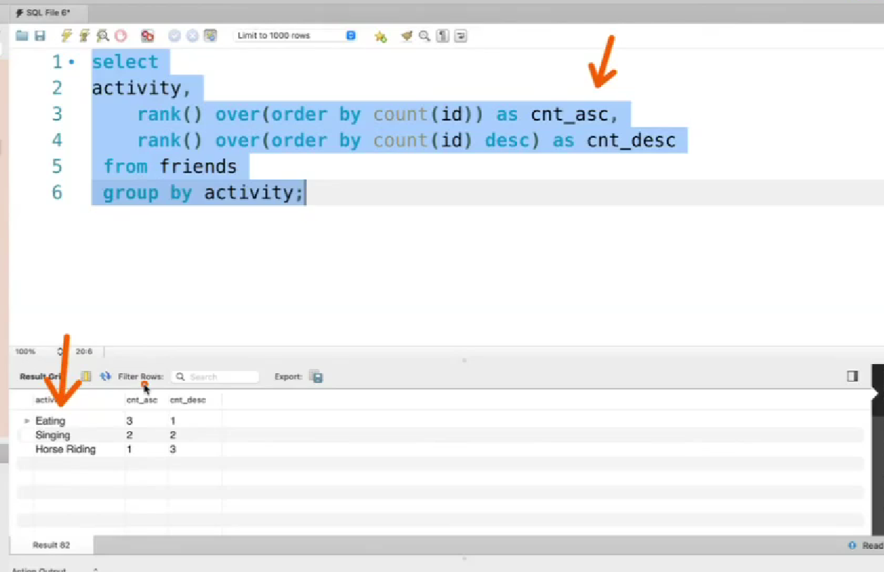

Remove from asc 1

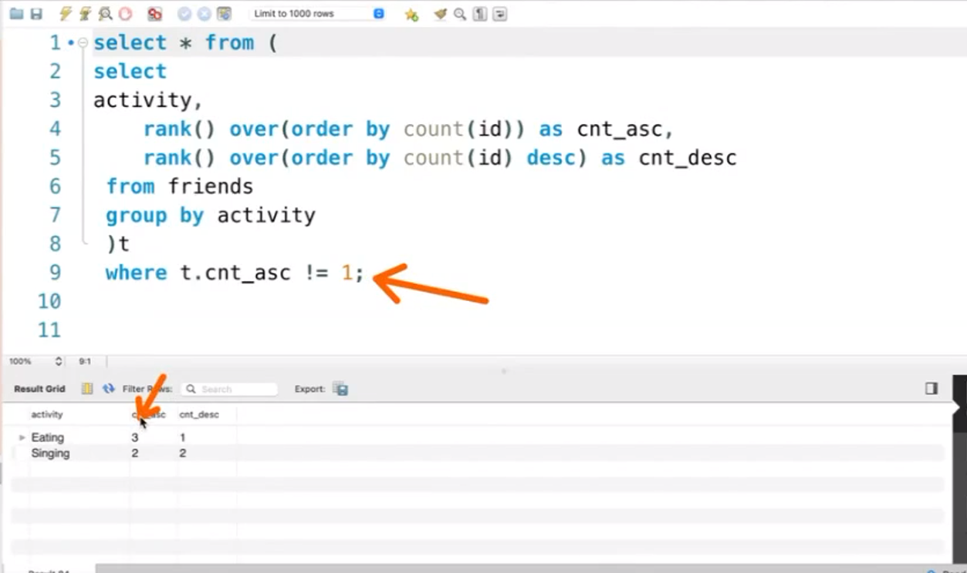

Same remove desc 1 eating

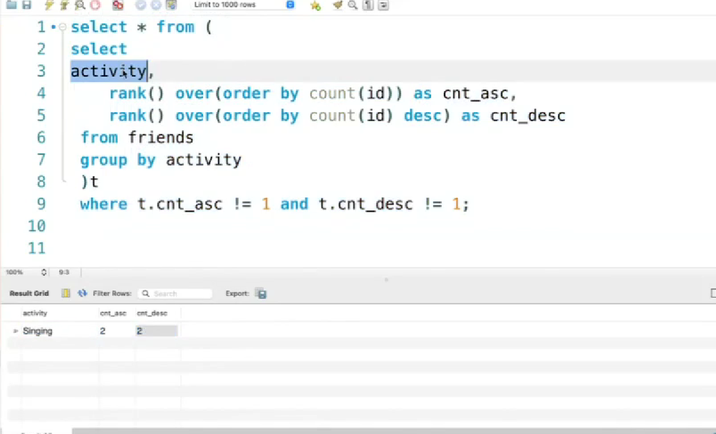

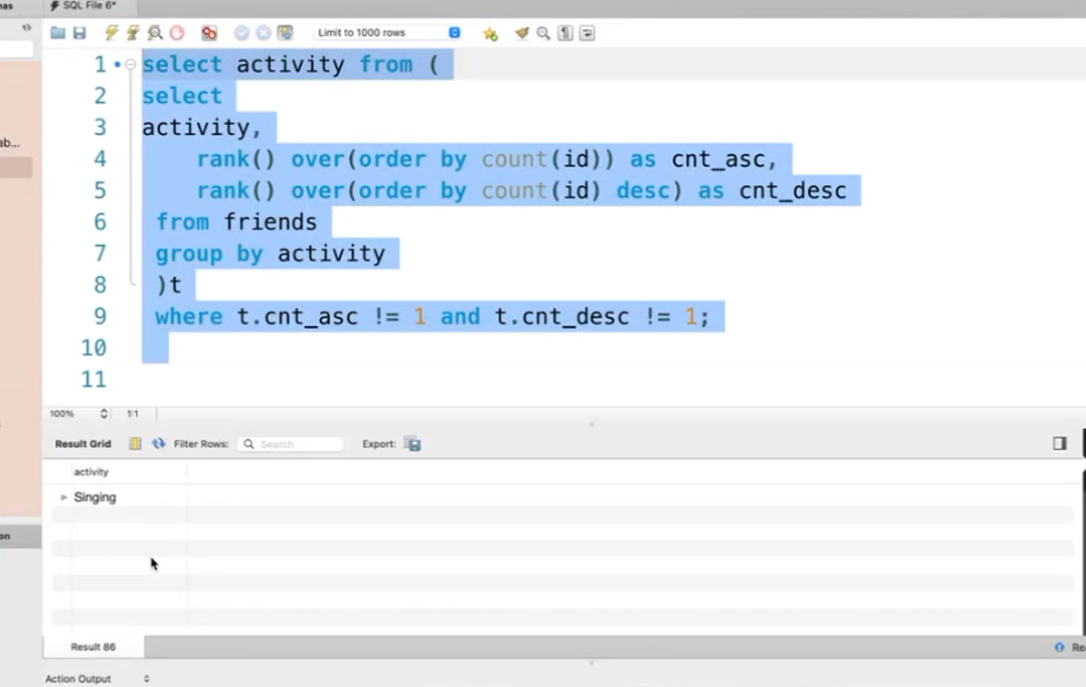

CTE method

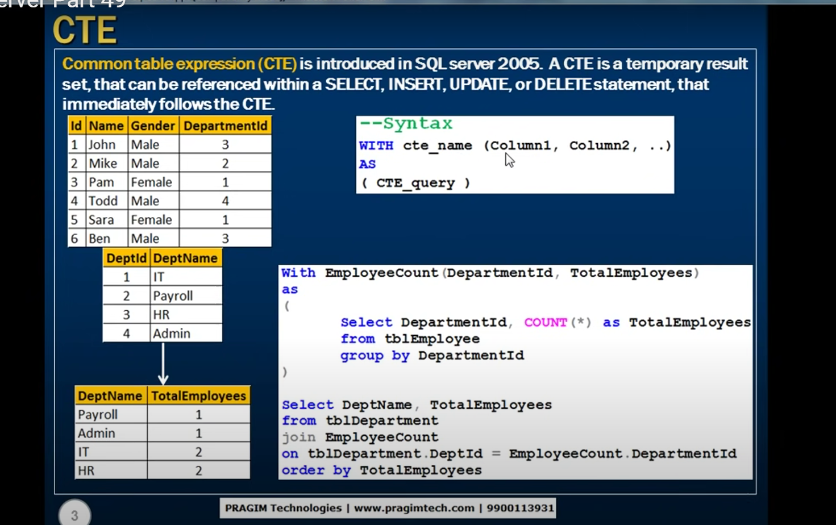

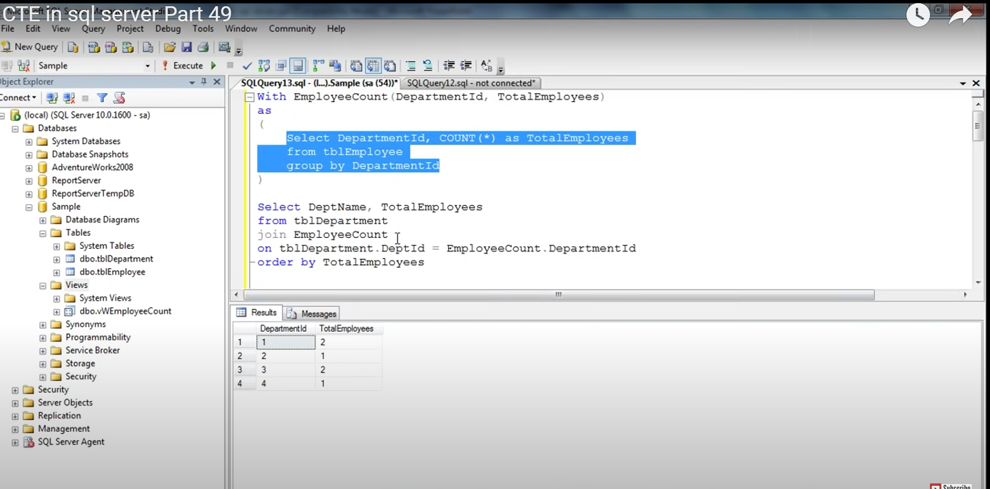

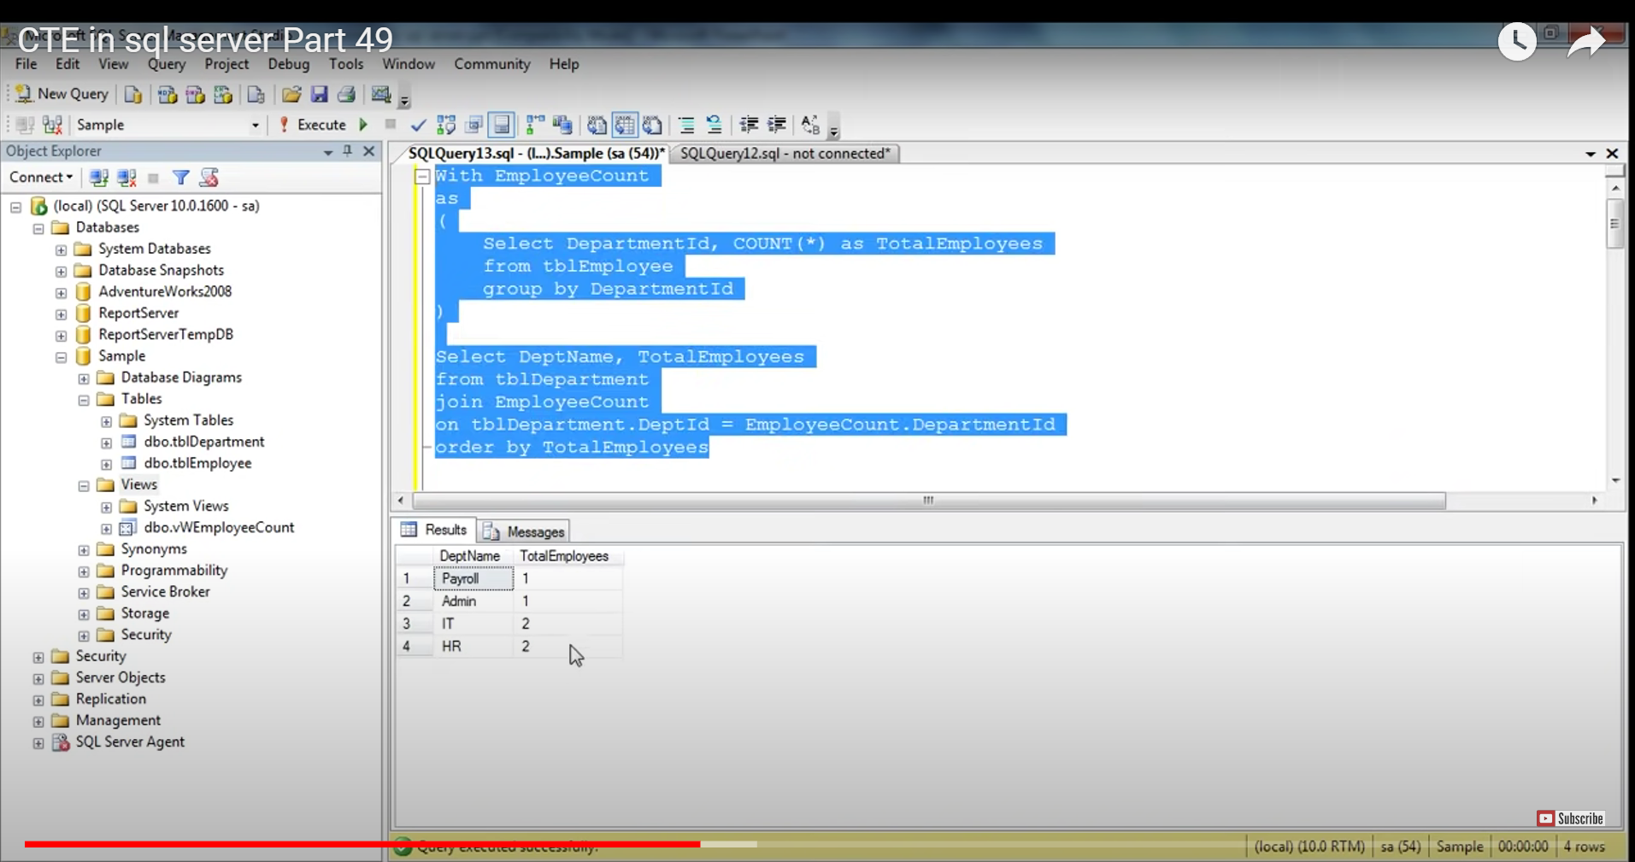

If the column name are not match we wil get error

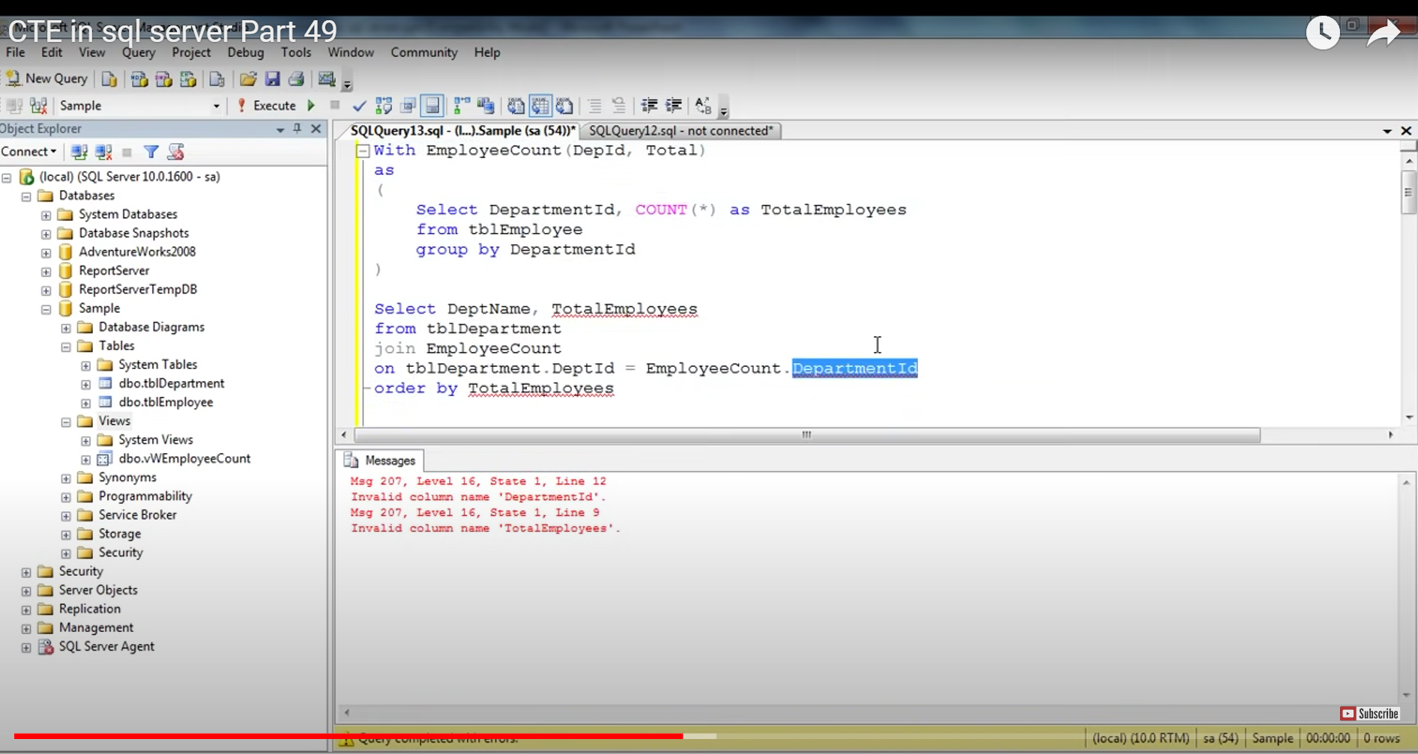

MULTIPLE CTE

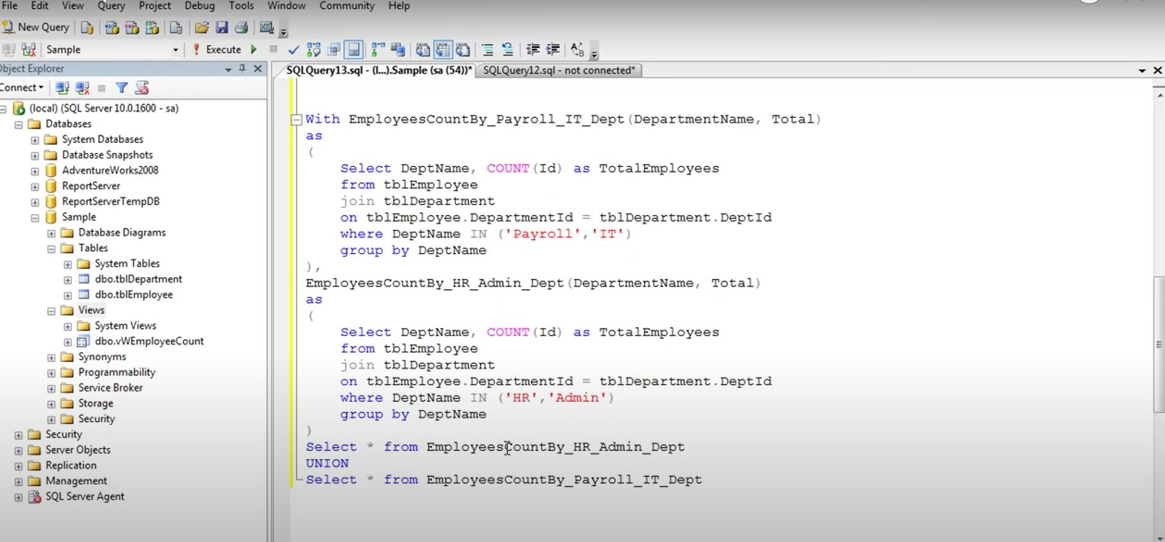

Since UNION is used here 2 select statement are working